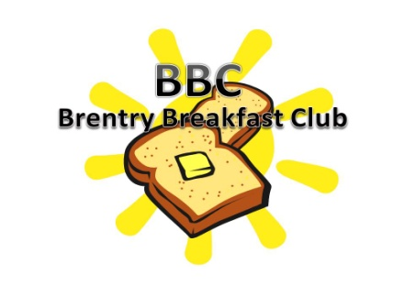
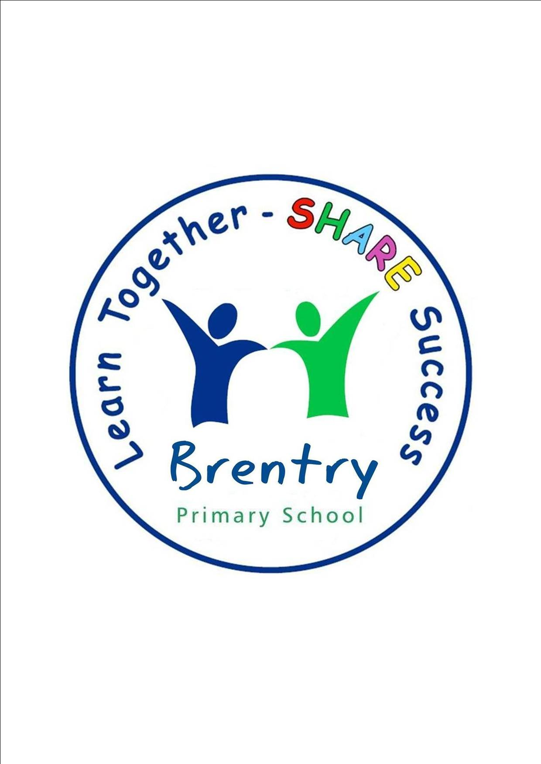

Dear Parent/ Carer

Did you know that Brentry Primary School has an excellent breakfast club facility?

If you are looking for childcare before the school day starts then we are here to help!!!

My name is Hayley Fitzgerald and I am the BBC (Brentry Breakfast Club) leader. I work alongside Mandy Hancox, Becky Lazard & Annette Vale Guerreiro who help provide a lovely breakfast and carry out a fantastic range of craft activities for the children.

Breakfast club is open in the main school hall from 7.45am – 8.45am Monday to Friday (apart from school holidays, in service days and polling days) for a mere £4 per child.
The price includes a filling breakfast from a selection of items each day and a drink (a sample menu can be found attached).

Children will have the opportunity to take part in a range of activities including arts and crafts, sports, cooking and socialising in a fun, friendly and safe environment.

If you require more information about the BBC you can look at the school website under parent info/Brentry Breakfast Club. The web page is updated with weekly planning sheets of what the children can expect to take part in whilst at the BBC. Keep an eye out for the BBC display board in the corridor which is updated with pictures of the children and what they have been getting up to each term. To register your child/ren to the BBC please fill out the form attached and pop into the school office. We look forward to welcoming your child to the BBC.

Warm Regards

Hayley Fitzgerald
BBC Leader

