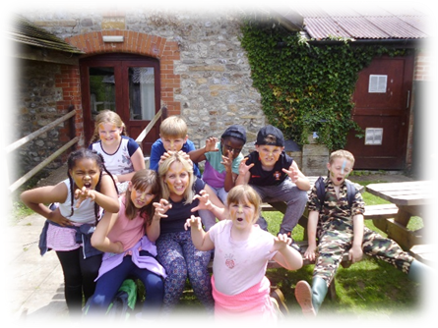
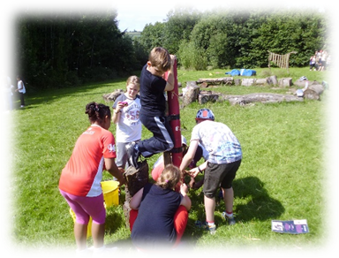
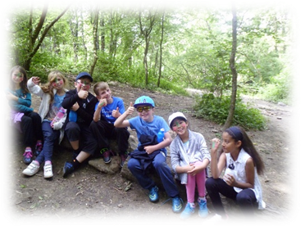

Year 4 Camp 2024 – The Magdalen Project
Dear Parents/Carers

The Year 4 Camp is getting nearer and nearer, so it is time that we asked you to complete an important admin task for us. This is the Medical & Diet Form, which is attached to this letter. That needs to be completed and returned to the class teacher or the office by June 21st at the latest. If your child needs any medication administered, please also complete the Admin of Medicines sheet and return that too.
We will be holding a meeting for parents of those children coming with us at 6.00pm on Thursday 13th June. It will be held in the hall.
On the back of this letter, you will find a kit list for camp. Please feel free to ask questions about this, or any other concerns, at the meeting.
Please ensure you have made the payments due for the camp via School Gateway. Thanks.

Best wishes

Mrs Collins

Magdalen Residential Visit Kit List

- A packed lunch for arrival
- A good, warm, waterproof jacket*
- Waterproof over trousers**
- Wellington boots with thick socks***
- Water bottle labelled with child’s name
- Warm hat
- 3-4 pairs of trousers (not jeans ideally)
- 3-4 t-shirts/ long sleeve shirts
- 2-3 jumpers/fleeces
- Plenty of socks (including a long thick pair to wear with Wellingtons)
- Underwear
- Pyjamas
- Small backpack (for packed lunch, clip boards etc)
- Outdoor shoes such as trainers or walking boots*** (designated to only be worn outside the building)
- Indoor shoes such as slippers or trainers (designated to only be worn inside the building)
- Trainers or shoes to wear on the coach
- 2 towels and a wash kit, including toothbrush
- Sun cream and sun hat
- Torch and spare batteries
- A game or book for quiet time e.g. top trumps (nothing valuable like PSPs though please)
- Three bin bags to take home dirty laundry, muddy waterproofs and muddy wellies
- Teddy bear!

*Waterproof jackets should be large enough to fit comfortably over several layers, and waterproof over trousers need to be able to fit over Wellingtons
** Waterproof over trousers can be bought from several high street camping shops such as Millets and Blacks. They are generally reasonably priced around £10 and along with a waterproof jacket will be one of the most important pieces of kit your child will need at Magdalen. Please ensure your child has a pair of over trousers with their name written inside them.
***All footwear must be well walked-in before your child comes to Magdalen.

Pupils are NOT allowed to bring mobile phones
Please ensure all items brought to Magdalen are clearly labelled with your child’s name

BRENTRY PRIMARY SCHOOL
CONFIDENTIAL MEDICAL INFORMATION AND CONSENT FORM
(FOR OFF SITE VISITS)

1. Visit to: Year 4 Camp – Magdalen Project

2. Dates of visit: From 17th to 19th July 2024

3. Pupil’s name:

4. Parent/carer
Name and address:

- Contact Tel No.s: Home ............................................. Mobile …………………………………………………….

6. Name and address of
family doctor:

7. Doctor/surgery Tel No: ......................................................

8. Has the above pupil had, or is still experiencing, any of the following?

Asthma or bronchitis YES NO
Sight or hearing impairments YES NO
Heart condition YES NO
Fits, fainting or blackouts YES NO
Severe Headaches YES NO
Diabetes YES NO
Allergies to any known drugs YES NO
Allergies to food, pollen, dust, insect stings YES NO
Anaphylactic shock YES NO
Recent Bed wetting YES NO
Sleep-walking YES NO
Travel sickness YES NO
Dental problems YES NO
Other illness or disability YES NO

9. If the answer to question 8 is YES, please give details in the space below:

.……

…

.

10. Has the pupil received vaccination against TETANUS in the last ten years? YES NO

11. Does the pupil require any special medical treatment? YES NO

12. Has the pupil received specific surgical or medical treatment in the past three months?
YES NO

13. Has the pupil been in contact with, or suffered from, any contagious or infectious
diseases in the past four weeks. YES NO

14. Is the pupil allergic to any medication? YES NO

15. If the answer to any of questions 11-14 is ‘YES’, please give details below, and specify which medical treatment/condition is involved or has been carried out. If they require or may require any medication whilst with us, please let us know what, how often and the dosage.

................................................................................................................................................

................................................................................................................................................

................................................................................................................................................

16. Does the pupil have any dietary requirements? YES NO
If ‘YES’, please give details:

……………………………………………………………………………………………………………………………………………..

……………………………………………………………………………………………………………………………………………..

If you prefer to discuss any medical matter privately with Mrs Collins, please make an appointment to do so.

DECLARATION

As parent / carer of ..................................................................................I consent to him/ her receiving any necessary medical treatment for any injury or illness during the above visit.

I also consent to him/ her participating in the variety of activities planned for the trip.

Signature of

Parent/carer..................................................... Date.............................................

(Name in capital letters )

NB. Please return this form, fully completed, as soon as possible and by June 21st at the latest. Your child will not be taken on camp if we haven’t received these details.

Administration of Medicines Consent Form

Child’s name _____________________________________

Date of Birth ______________________________________

The following medicine(s) will be self-administered / needs to be administered from 17th - 19th July:

 | Medicine 1 | Medicine 2 | Medicine 3
Self-administered (SA) or needs administering (NA)?

Condition
e.g. hay fever, headaches

Type of medicine
eg eye drops, inhaler

Name of medicine
eg Ritalin, Amoxicillin
Dosage eg 5 ml, 1 drop

Time (s) to be
Administered

I give express written consent for the school to administer / to allow my child to self-administer this medicine as detailed above. I agree to indemnify the school against any claim arising as a result of this agreement.

Signature _____________________________

Parent/ Carer Full Name ___________________________________________

Date ______________________________

If your child has any medicine it needs to be clearly marked/named in a secure bag. Any medication requiring adult administration should be handed to Mrs Collins on the morning of departure.

