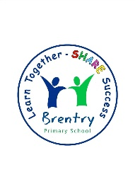

Curriculum Overview

Spring Term 3 - 2024

Year 2

|  |  |  |  |
| --- | --- | --- | --- |
| **English**  Reading   * **A Bear called Paddington** by Michael Bond. * **A Walk in London** by Salvatore Rubbino * Making inference and answering retrieval questions. * Reading words with two or more syllables * Predicting what might happen next   Writing   * Letter writing * Diary writing linked to the Fire of London * Character and setting descriptions * Paddington Bear’s next adventure   SPAG   * Noun phrases * Plurals * Different types of sentences * Capital letters, full stops, commas, question marks and exclamations * Past/present tense verbs * Using conjunctions | | | **Maths**  Money:   * Recognising coins, pounds and notes * Make the same amount * Compare amounts of money * Finding total of amounts * Giving change * Solving two-step problems   Multiplication and Division:   * Recognise, make and add equal groups * Use arrays * Learn the 2, 5 and 10 times table facts * Making equal groups – sharing * Making equal groups – grouping * Divide by 2, 5 and 10 * Odd and even numbers |
| **Science**  Animals including humans | | | **ICT**  Programming Turtle logo and Scratch |
| **History**  The Great Fire of London | | **Religious Education**  Who is a Muslim and what do they believe? | |
| **Art**  Portraits | | **Music**  Sing up  Carnival of the animals (continued) | |
| **Physical Education**  Gymnastics and dance | **PSHE**  Dreams and goals | **How you can help at home**  Ensure your child is reading regularly  Offer support with spellings | |