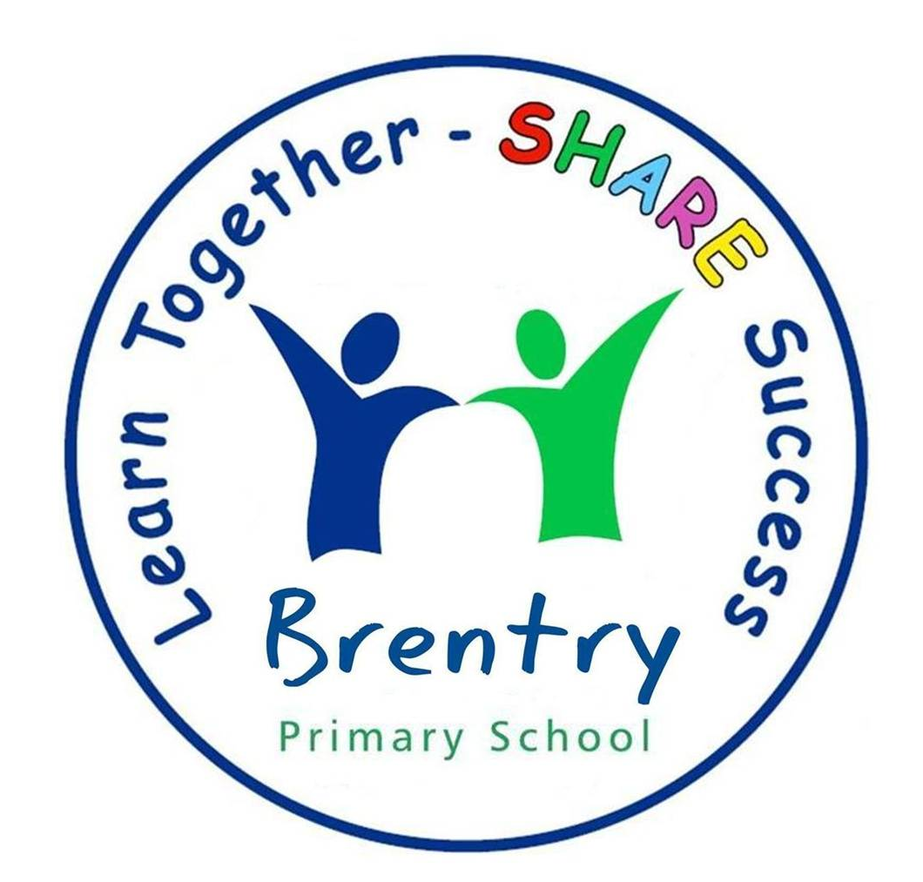

Dear Parent/carer,

Welcome to Year 2 – we hope you have had a lovely summer. Our batteries have been recharged and we are excited to welcome all the children back to school on Tuesday. We will be having a back to school meeting on Tuesday 12th September but to keep us going till then we are going to outline some of the expectations of being in Year 2 in order to help the next few weeks run smoothly.

Staff
Mrs Moore
For those who haven’t already met me, I have been teaching here at Brentry for 15 + years (I suddenly feel very old writing that!) and have taught in both key stages. I love this school and count myself very lucky to be working in the best year group (I may be a little biased). I will be teaching on a Monday, Tuesday and alternate Wednesdays. I have two children, a football mad boy who is 8 and a dancing girl who is 5. Mrs Ford and I have already had lots of planning meetings and will be working in union to deliver the highest quality of teaching to all of the children in the class.

Mrs Ford
I have been teaching for 15+ years too and I joined Brentry five years ago. I have three boys of my own, which keeps me busy on the days I am not teaching. In fact, it’s sometimes a relief to be in work! We are a great team and both experienced in teaching Year 2. I am teaching on a Thursday, Friday and alternate Wednesdays.

Mrs Tucker is our trusty sidekick; she is the ‘Mary Poppins’ of Year 2. She is our highly experienced teacher assistant and will be working in the class all day Monday to Thursday. Mrs Caton will work in the classroom every Friday.

We are a friendly bunch and are always here to support you. Please do pop in and say hello!

Reading Books:
We will be sorting out the reading books, matching appropriate books to match the children’s phonics ability. All children should receive a reading book by the end of the week. Please don’t worry if your child is given a different level to what they were on in Year 1, sometimes we have to refresh their memory by revisiting a level but they will quickly move onto the next stage. As a reminder, if your child is reading a book on level 2c, b, a or 3c, b, a we would like them to have read their reading book 3 times before getting it changed to a new one. All children are expected to read as often as possible. When they have finished their book, they place their reading book in the reading tray at the front of the classroom to show us that it needs to be changed. We run a reward system for children, who regularly read at home: When the children read 10 times at home they receive a bronze certificate, 25 times they receive a silver certificate and 50 times a gold certificate! Please use your child’s reading record to communicate how your child is coping with their reading book at home.

Homework:
The children will have a weekly spelling test on a Wednesday morning. The children will need to show that they have practised their spellings by copying the word list three times in their spelling book. There will be new spellings set on 13th September, they will then be tested on the following Wednesday (20th).

P.E Kits:
The children have PE on Monday and Wednesday. We will try to have our PE sessions outside as much as the weather permits. On these days, the children will be expected to wear their PE kits for the entire day. Our first PE session will be on Wednesday 6th September. Later on this term we will be starting our swimming sessions (more information to follow).

Snacks:
Please feel free to provide your child with a healthy snack for playtime. We encourage the children to bring in their own water bottles that have their names clearly labelled on them.

Belongings:
There is no need for children to bring in any personal belongings such as pencil cases etc. We will provide the children with all the resources they need.

Curriculum:
We have fun, exciting, engaging topics this year which the children will enjoy finding out all about. Please check our curriculum overview that is on our class webpage and tells you everything we are covering this term.

We hope this has made our year two routines a little clearer. If circumstances change, we will keep you updated and please check on class webpage regularly. Looking forward to seeing you on Tuesday.

Claire Moore & Laura Ford

