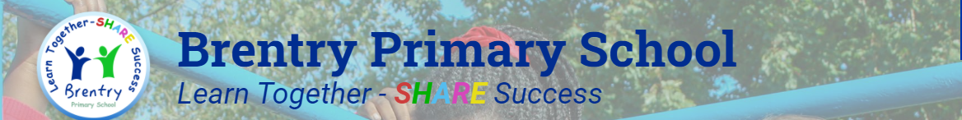

**Geography at Brentry Primary School**

**Rationale**

*The teaching and learning of Geography at Brentry Primary school helps us achieve our school Mission. It impacts directly on the areas of Achievement, Responsibility and Enjoyment, helping pupils to understand the complexity of our world* and to appreciate the diversity of cultures that exists across continents.

We aim to deliver an **engaging, creative** geography curriculum which harnesses pupils’ **natural curiosity** and **inspires a passion** to find out more about the world and the people who live there. Pupils are encouraged to **investigate similarities and differences** between areas of the globe and its inhabitants, and how places are **interconnected**, in turn developing an **understanding, appreciation and tolerance** of those from different backgrounds. They will be taught about the interrelation between **human and physical geography**, enabling them to consider the impact that they themselves have on the world, both at a local and global level.

As they progress through the school, pupils will increase their knowledge of places around the world and what they are like, using **geographical enquiry skills to question, analyse and present data**. Through **fieldwork** and other geographical techniques, pupils will develop key concepts such as the ability to **investigate places and patterns** as well as to communicate geographically, using increasingly refined **geographical vocabulary**. Through this, they will develop the ability to **express their own opinions** on issues in society and the environment, paving the way for them to be instigators of change and progress in the future.



**Intent**

The Geography curriculum is taught in blocked units over terms 3 and 4, providing the children with the best opportunity to recall, embed and build upon previous learning as they move across a topic. The schemes of work covered are predominantly taken from Twinkl *PlanIt* resources, as these sequences of learning are proven to ensure progression of skills across Keystages 1 and 2. Each unit, however, has been adapted by the teacher to best support and challenge their cohort.

**National Curriculum Content Coverage**

In Keystage 1, children are taught *concentrically*: school 🡪 UK 🡪 the world.

**EYFS:**

* **ELG: Explore natural world, making observations and drawing pictures** Muddy Monday + Class Tree
* **ELG: Similarities/ differences local/contrasting environments** Marvellous Me + Animals (hot/cold)

**Year 1:**

* **NC: Place Knowledge**: Our School
* **NC: National Locational Knowledge:** Our Country  
  **NC: Human/Physical Geography**

**Year 2:**

* **NC: Global Locational Knowledge:** What a Wonderful World
* **NC: Human/Physical Geography:** Sensational Safari

In Keystage 2, there is a greater emphasis on thematic learning and comparison. Units explore the knowledge required to pose geographically-valid questions and the skills needed to investigate them.

**Year 3:**

* **NC: North and South American Locational Knowledge** Rainforests

**NC: Compare Place Knowledge – UK and South America**

* **NC: Human/Physical Geography** Land Use

**Year 4:**

* **NC: Locational Knowledge (position and significance):** All Around the World
* **NC: Human/Physical Geography:** Extreme Earth

**Year 5:**

* **NC: National Locational Knowledge:** Modern Britain

**NC: Human/Physical Geography**

* **NC: European Locational Knowledge:** Exploring Eastern Europe

**NC: Human/Physical Geography**

**NC: Compare Place Knowledge – UK and Europe**

**Year 6:**

* **NC: Human/Physical Geography:** Raging Rivers
* **NC: Human/Physical Geography:** Our Changing World
* **National and Global Locational Knowledge**

**Progression of Skills**

|  |  |  |  |
| --- | --- | --- | --- |
|  | **KS1** | **LKS2** | **UKS2** |
| **Locational Knowledge** | Building on EYFS knowledge of their own environment, children start to learn the names of key places in the UK beyond their immediate environment. Children also learn the names of the world’s oceans and continents.  **KS1 Geography National Curriculum**  Pupils develop contextual knowledge of the location of globally significant places. They should develop knowledge about the world, the United Kingdom and their locality.  Children can:   1. name and locate the world’s seven continents and five oceans; 2. name, locate and identify characteristics of the four countries and capital cities of the United Kingdom and its surrounding seas; 3. use key vocabulary to demonstrate knowledge and understanding in this strand: United Kingdom, England, Scotland, Wales, Northern Ireland, town, city, village, sea, beach, hill, mountain, London, Belfast, Cardiff, Edinburgh, capital city, world map, continent, ocean, Europe, Africa, Asia, Australasia, North America, South America, Antarctica. | Building on KS1 knowledge of the UK, children begin to explore more of the world, understand how the world has zones and the significance of those zones. Locating places and features accurately on maps also becomes a focus.  **KS2 Geography National Curriculum**  Pupils should extend their knowledge and understanding beyond the local area to include the United Kingdom and Europe, North and South America.  Children can develop contextual knowledge of the location of globally significant places – both terrestrial and marine.  Children develop their understanding, recognising and identifying key physical and human geographical features.  Children can:   1. locate the world’s countries, using maps to focus on South America, concentrating on environmental regions and key physical and human characteristics; 2. name and locate counties and cities of the United Kingdom, identifying human and physical characteristics including hills, mountains, rivers and seas, and how a place has changed; 3. identify the position and significance of latitude, longitude, Equator, Northern Hemisphere, Southern Hemisphere, the Tropics of Cancer and Capricorn, Arctic and Antarctic Circle, the Prime/Greenwich Meridian and time zones; 4. use key vocabulary to demonstrate knowledge and understanding in this strand: county, country, town, coast, physical features, human features, mountain, hill, river, sea, climate, tropics, tropical, of latitude, longitude, Equator, Northern Hemisphere, Southern Hemisphere, the Tropics of Cancer and Capricorn, Arctic and Antarctic Circle. | Children begin to explore Eastern Europe and South America using maps to find these locations. Children use their knowledge of longitude, latitude, coordinates and indexes to locate places. Compared to Lower KS2, children focus more on finding locations outside of the UK.  **KS2 Geography National Curriculum**  Pupils should extend their knowledge and understanding beyond the local area to include the United Kingdom and Europe, North and South America. They will begin to explore the concept of tourism and its impact. Children can develop contextual knowledge of the location of globally significant places – both terrestrial and marine.  Children develop their understanding of recognising and identifying key physical and human geographical features of the world; how these are interdependent and how they bring about spatial variation and change over time.  Children can:   1. use maps to locate the world’s countries with a focus on Eastern Europe and South America, concentrating on their environmental regions, key physical and human characteristics, countries, and major cities; 2. name and locate counties and cities of the United Kingdom, identifying their physical features, including mountains, and rivers, and land-use patterns; showing change over time; 3. identify the position and significance of latitude, longitude, Equator, Northern Hemisphere, Southern Hemisphere and use longitude and latitude to find locations on a map; 4. use key vocabulary to demonstrate knowledge and understanding in this strand: atlas, index, coordinates, latitude, longitude, contour, altitude, peaks, slopes, continent, country, city, North America, South America, border, key. |

|  |  |  |  |
| --- | --- | --- | --- |
| **Place Knowledge** | Children begin to compare places in the UK with a place outside of the UK. This builds on EYFS knowledge and understanding of the world, people and communities. Children can apply the skills of observing similarities and differences to places as well as people.  **KS1 Geography National Curriculum**  Pupils develop contextual knowledge of the location of globally significant places. They should develop knowledge about the world, the United Kingdom and their locality. Children begin to understand basic vocabulary relating to human and physical geography.  Children can:   1. compare the UK with a contrasting country in the world; 2. compare a local city/town in the UK with a contrasting city/town in a different country; 3. use key vocabulary to demonstrate knowledge and understanding in this strand: South America, London, Brasilia, compare, capital city, China, Asia, country, population, weather, similarities, differences, farming, culture, Africa, Kenya, Nairobi, river, desert, volcano. | Children develop vocabulary relating to physical and human geographical features from KS1. They begin to develop the skills of comparing regions, by focusing on specific features. Children focus on comparing regions of the UK in depth and start to look at an area outside of the UK.  **KS2 Geography National Curriculum**  Children can understand geographical similarities and differences through the study of human and physical geography of a region of the United Kingdom, a region in a European country and a region within North or South America.  Children can:   1. understand geographical similarities and differences through the study of human geography of a region of the United Kingdom; 2. explore similarities and differences, comparing the human geography of a region of the UK and a region of South America; 3. understand geographical similarities and differences through the study of physical geography of a region of the United Kingdom; 4. explore similarities and differences comparing the physical geography of a region of the UK and a region of South America; 5. use key vocabulary to demonstrate knowledge and understanding in this strand: Amazon rainforest, Sherwood Forest, Sheffield, city, Yorkshire, physical features, human features, landscape, feature, population, land use, retail, leisure, housing, business, industrial, agricultural. | Children develop their analytical skills by comparing areas of the UK with areas outside of the UK. They will have a deeper knowledge of diverse places, people, resources, natural, and human environments. They can make links to places outside of the UK and where they live. Children are encouraged to conduct independent research, asking and answering questions.  **KS2 Geography National Curriculum**  Children can understand geographical similarities and differences through the study of human and physical geography of a region of the United Kingdom, a region in a European country, and a region within North or South America.  Children can:   1. understand geographical similarities and differences through the study of human geography of a region of the United Kingdom, a region of Eastern Europe and South America; 2. understand geographical similarities and differences through the study of physical geography of a region of the United Kingdom, a region of Eastern Europe and South America; 3. use key vocabulary to demonstrate knowledge and understanding in this strand: latitude, Arctic Circle, physical features, climate, human geography, land use, settlement, economy, natural resources. |

|  |  |  |  |
| --- | --- | --- | --- |
| **Human and Physical Geography** | Building on EYFS knowledge of how environments may vary. Children begin to learn about the physical and human features of geography.  **KS1 Geography National Curriculum**  Children will understand key physical and human geographical features of the world. They identify seasonal and daily weather patterns.  Children can:   1. identify seasonal and daily weather patterns in the United Kingdom and the location of hot and cold areas of the world in relation to the Equator and the North and South Poles; 2. use basic geographical vocabulary to refer to key physical features, including: beach, cliff, coast, forest, hill, mountain, sea, ocean, river, soil, valley, vegetation, season and weather; 3. use basic geographical vocabulary to refer to key human features, including: city, town, village, factory, farm, house, office, port, harbour and shop. | Children have a stronger understanding of the difference between physical and human geography. They use more precise vocabulary, explaining the processes of physical and human geography and their significance. They learn more about extreme weather, the processes involved in the causes and effects of extreme weather, as well as beginning to understand the impact of humans on the earth.  **KS2 Geography National Curriculum**  Children locate a range of the world’s most significant human and physical features. Explain how physical features have formed, why they are significant and how they can change.  Explain the impact of humans on the earth in terms of land use, settlements and their direct connection to physical changes.  Children can:  **describe and understand key aspects of:**   1. physical geography, including: climate zones, biomes, volcanoes, tornadoes, tsunamis, earthquakes and the water cycle; 2. human geography, including: types of settlement and land use; 3. use key vocabulary to demonstrate knowledge and understanding in this strand: mantle, outer core, inner core, magma, volcano, active, dormant, extinct, earthquake, epicentre, shock wave, magnitude, tsunami, tornado, climate, tropics, deforestation, evaporation, water cycle, evaporation, condensation, precipitation, cooling, filter, pollution, settlement, settler, site, need, shelter, food. | Children deepen their understanding of the difference between physical and human geography. They can explain the terminology of both aspects of geography with a range of examples. They spend time exploring human geography and the impact humans have on the world. They focus on trade links, resources and the distribution of resources around the world. Children also learn about the different types of mountains.  **KS2 Geography National Curriculum**  Children will locate a range of the world’s most significant human and physical features. Explain how physical features have formed, why they are significant and how they can change. Children can understand how these are interdependent and how they bring about spatial variation and change over time. Children will deepen their understanding of the interaction between physical and human processes, and of the formation and use of landscapes and environments.  Children can:  **describe and understand key aspects of:**   1. physical geography, including: climate zones, biomes and vegetation belts, mountains and the water cycle; 2. human geography, including: types of settlement and land use, economic activity including trade links, and the distribution of natural resources including energy, food, minerals and water; 3. use key vocabulary to demonstrate knowledge and understanding in this strand: environmental disaster, settlement, resources, services, goods, electricity, supply, generation, renewable, non-renewable, solar power, wind power, biomass, origin, import, export, trade, efficiency, conservation, carbon footprint, peak, plateau, fold mountain, fault-block mountain, dome mountain, volcanic mountain, plateau mountain, tourism, positive, negative, economic, social, environmental. |

|  |  |  |  |
| --- | --- | --- | --- |
| **Geographical Skills and Fieldwork** | Building on EYFS knowledge of their own environment, children begin to use maps to locate places and name features using keys and symbols. Children also begin to look at how the environment has changed over time.  **KS1 Geography National Curriculum**  Children can interpret geographical information from a range of sources. They can communicate geographical information in a variety of ways.  Children can:   1. use world maps, atlases and globes to identify the countries, continents and oceans studied at this key stage; 2. use simple compass directions and locational and directional to describe the location of features and routes on a map; 3. devise a simple map; and use and construct basic symbols in a key; 4. use simple fieldwork and observational skills to study the geography of the surrounding area, including key human and physical features, using a range of methods; 5. use key vocabulary to demonstrate knowledge and understanding in this strand: compass, 4-point, direction, North, East, South, West, plan, record, observe, aerial view, key, map, symbols, direction, position, route, journey, the UK, changes, tally chart, pictogram, world map, country, continent, human, physical. | Children begin to develop their map skills. They will be able to identify features on a map through the use of symbols and keys. Children begin to use fieldwork skills to monitor and explain patterns in human and physical features.  **KS2 Geography National Curriculum**  Children collect, analyse and communicate a range of data gathered through fieldwork that deepens their understanding of geographical processes. They interpret a range of sources of geographical information including maps, diagrams, globes, aerial photographs and Geographical Information Systems (GIS).  Children can:   1. use maps, atlases, globes and digital/computer mapping to locate countries and describe features studied; 2. use symbols and keys (including the use of Ordnance Survey maps), to build their knowledge of the United Kingdom and the wider world; 3. use fieldwork to observe and present the human and physical features in the local area using sketch maps, plans and digital technologies; 4. use key vocabulary to demonstrate knowledge and understanding in this strand: sketch map, map, aerial view, feature, annotation, landmark, distance, key, symbol, land use, urban, rural, population, coordinates. | Children build on their map skills by communicating locations through grid references and coordinates. They also explain what makes a good map symbol and why. Children focus on observing and recording the changes of human features over time, for example trade patterns.  **KS2 Geography National Curriculum**  Children will become confident in collecting, analysing, and communicating a range of data. Children can explain how the Earth’s features at different scales are shaped, interconnected and change over time.  Children can:   1. use maps, atlases, globes and digital/computer mapping to locate countries and describe features; 2. use the eight points of a compass, four and six-figure grid references, symbols and key (including the use of Ordnance Survey maps) to build their knowledge of the United Kingdom and the wider world; 3. use fieldwork to observe, measure, record and present human features using a range of methods, including sketch maps, plans and graphs, and digital technologies; 4. use key vocabulary to demonstrate knowledge and understanding in this strand: atlas, index, coordinates, latitude, longitude, key, symbol, Ordnance Survey, Silva compass, legend, borders, fieldwork, measure, observe, record, map, sketch, graph. |

**N.B Skills Progression:**

This table is taken from the Twinkl Geography *Planit!* Resource pack. It confirms the skills progression which underpins the Twinkl schemes of work used by Brentry. Original units, which have been tailored to classes at Brentry, have also been written to meet these objectives.

**Evidence of National Curriculum Skills Coverage:**

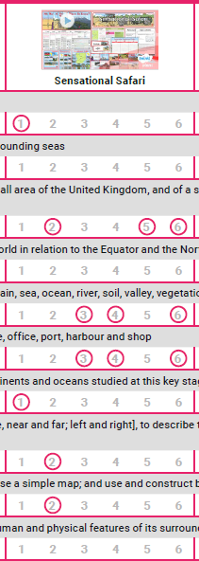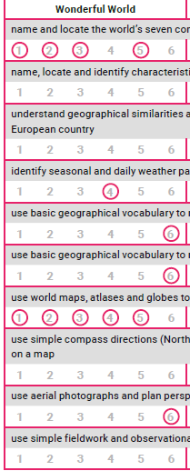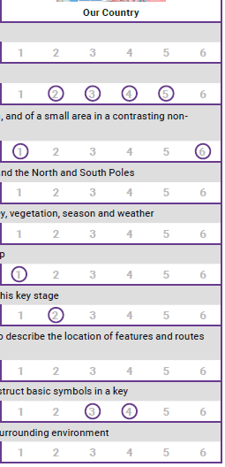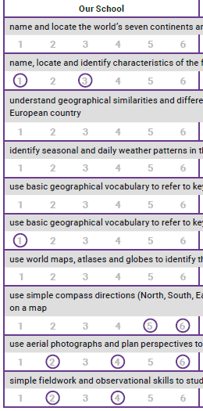KS1:

Use simple fieldwork and observational skills to study the geography of the school and grounds and physical features of the surrounding area

Use aerial photographs and plan perspectives to recognise landmarks and basic human/physical features, devise a simple map and use a key

Use world maps, atlases and globes to identify the UK and its countries, as well as the countries, continents and oceans of the world

Use simple compass directions (N, S, E, W) and locational and directional language to describe the location of features and routes on a map

Use basic geographical vocab to refer to key physical features: beach, cliff, coast, forest, hill, mountain, sea, ocean, river, soil, valley, vegetation

Use basic geographical vocab to refer to key human features: city, town, village, factory, farm, house, office, port, harbour and shop

Identify seasonal and daily weather patterns in the UK and the location of hot and cold areas in the world in relation to equator and N/S poles

UK vs Europe: compare similarities and differences of human and physical geography

Name and locate the world’s seven continents and five oceans

Name, locate and identify characteristics of the four countries and capital cities of the UK and its surrounding seas

**N.B Cross-Curricular Coverage:**

**T2 and T4:** Year 1 discuss **local weather** as part of Science study of the **changing seasons**. Year 2 consider how ‘The Wild Place’ has recreated the **physical geography** of animals’ native habitats in contrast to the UK’s natural features.

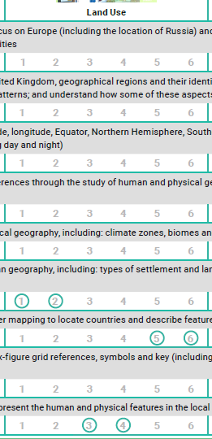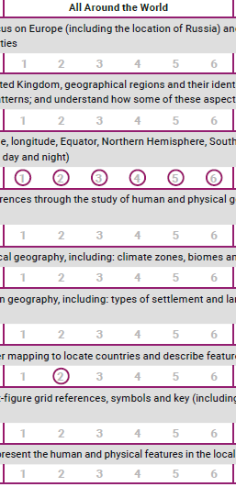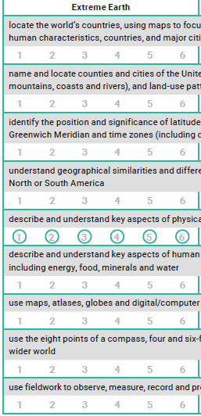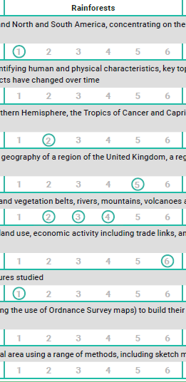LKS2:

Use fieldwork to observe, measure, record and present the human and physical features in the local area using a range of methods: maps, plans, graphs.

Use eight points of a compass, four and six-figure grid references, symbols and key (incl OS maps) to build knowledge of UK and wider world

Use maps, atlases, globes and digital/computer mapping to locate countries and describe features studied

Understand key aspects of human geography: types of settlement, land use, economic activity, trade links, natural resources.

Understand key aspects of physical geography: climate zones, biomes, vegetation belts, rivers, mountains, volcanoes, earthquakes, water cycle.

Compare the sims/diffs of human/physical geography of UK region, a European region and region of N/S America.

Locate countries/UK cities, their geographical regions, human/physical characteristics, key topographical features and land use patterns over time.

Identify the position and significance of latitude, longitude, equator, N/S hemisphere, the Tropics of Cancer/Capricorn, Arctic/Antarctic and time zones.

Locate countries using maps to focus on Europe and N/S America. Focus on environmental regions, key physical/human characteristics and major cities.

**N.B Cross-Curricular Coverage:**

**T1:** Year 3s study Bronze Age copper mining: **settlements near natural resources and land use over time**. Similar consideration of physical 🡪 human geography in their study of hill forts. Year 4s study the emigration of the Angles, Jutes, Danes and Vikings due to **natural resources and land use**.

**T2:** Year 3s study the expansion of the Roman Empire, involving **location of countries and cities in Europe**, as well as the changing land use and need for roads (**trade links and economic activity**). Year 4s study Ancient Egyptian life by considering how the **climate and biome dictated land use and trade**.

**T6:** Year 4s complete orienteering style activities while on camp. Their **fieldwork** involves using a map to plan routes and locate POIs in relation to landmarks and topographical features.

UKS2:

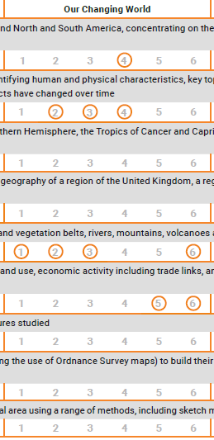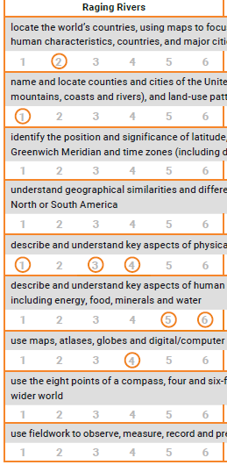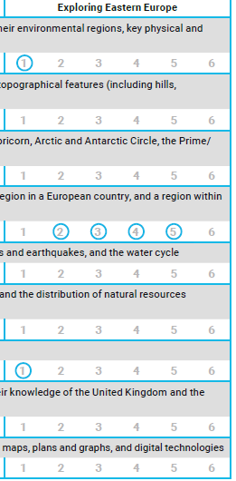

Locate countries using maps to focus on Europe and N/S America. Focus on environmental regions, key physical/human characteristics and major cities.

Modern Britain



**N.B Cross-Curricular Coverage:**

**T1:** Year 5s study the expansion of the Grecian Empire, involving **location of countries and cities in Europe**. Year 5s locate ancient Maya on a map of the world/ South America. Year 6s also research the importance of maize and cocoa: **climate/biome, land use, economic activity, natural resources and trade links**.

**T2:** Year 5s study the transatlantic slave trade: plantations (**biomes, natural resources, land use**) and the Middle Passage (**economic activity and trade links**). Year 6 study the cause of WW1 (**locate involved countries on maps)** and the reality of trench warfare (the regional strategies in relation to **topographical features**).

**T6:** Year 6s complete orienteering style activities while on camp. Their **fieldwork** involves using a map to plan routes and locate POIs in relation to landmarks and topographical features.

Use fieldwork to observe, measure, record and present the human and physical features in the local area using a range of methods: maps, plans, graphs.

Use eight points of a compass, four and six-figure grid references, symbols and key (incl OS maps) to build knowledge of UK and wider world

Use maps, atlases, globes and digital/computer mapping to locate countries and describe features studied

Understand key aspects of human geography: types of settlement, land use, economic activity, trade links, natural resources.

Understand key aspects of physical geography: climate zones, biomes, vegetation belts, rivers, mountains, volcanoes, earthquakes, water cycle.

Compare the sims/diffs of human/physical geography of UK region, a European region and region of N/S America.

Identify the position and significance of latitude, longitude, equator, N/S hemisphere, the Tropics of Cancer/Capricorn, Arctic/Antarctic and time zones.

Locate countries/UK cities, their geographical regions, human/physical characteristics, key topographical features and land use patterns over time.

**Access to Learning**

Another reason for choosing to follow *Twink Planit!* is the **high quality resourcing** which is provided in support of their schemes of work. For each lesson, Twinkl provides 3 **differentiated worksheets** to ensure all children, whether they are working below, at or above the expected standard, are able to access their learning at a level of appropriate challenge. Teachers use their judgement to select which of these sheets they will provide or adapt their own resources from the lesson plans, so as to tailor them to their class’ needs.

Twinkl’s colourful presentations are accompanied by supporting classroom displays. Teachers are encouraged to select images and vocabulary from these packs to be included in their **working walls**. This allows for a cohesive message to be relayed across Geography lessons, as well as through the learning environment between lessons. Working walls support SEND learners to recall and embed previous learning using **recurring images** and providing a space to record the **class’ learning journey** across a topic. Similarly, working walls include **key words and vocabulary** in particular support of EAL learners.

**Cultural Capital**

At Brentry, our Geography units have been carefully selected so as to maximise the cultural capital of our students. Year 1 is about the self: geography provides students an opportunity to identify with their school and country. The children get to know their local area with a visit to the park. If Year 1 is about ‘I’, then Year 2 is about ‘we’. In Year 2, students are introduced to the global community of which we are a part. They explore how and why journeys are made around the world and celebrate familial/ancestral countries of origin, what continent they are a part of and what their climate is like. The Year 2 visit to ‘The Wild Place’ is not only an enriching experience (from a geographical, scientific and PP perspective), but also provides a tangible means of observing and experiencing the contrasting environments in existence on planet Earth and studied in Geography. **At Key Stage 1, the *cultural capital* gained through Brentry’s Geography curriculum is through an exploration of identity: where am I and where do I fit in to the local, national and global community?**

**The three residential camps – conducted over the course of KS2 at Brentry - constitute prime opportunities for *cultural capital*, as they expose students to people, activities and sights they may otherwise not encounter first-hand.** In Year 4, the children visit Magdalen Farm. The students are taught about the farm’s ethos of sustainability and organic food culture. They eat the food they water and harvest on-site and explore the farm’s 80 acres using a map, compass and walkie-talkie (as there is no 4G here)! In France, the Year 5s experience first-hand the language and culture studied in their ‘European Cities’ topic. While at the Forest of Dean, support the conservationists at the study centre to monitor the local environment through field work.  
 **Moreover, the *cultural capital* gained through Brentry’s KS2 Geography curriculum is through an understanding of how human and physical geography interrelate and the impact this has on how we live – or how we *should* live. Students are challenged to consider the consequences of land use, territories and economic activity in relation to ethical models, such as sustainability and our British Values.**

**Enrichment Experiences**

|  |  |  |
| --- | --- | --- |
| EYFS | Theme Days (eg. Antarctica) |  |
| Year 1 | Exploring the local area (visit to the park) |  |
| Year 2 |  | The Wild Place |
| Year 3 |  |  |
| Year 4 |  | Magdalen Farm (Residential Camp) |
| Year 5 |  | France (Residential Camp) |
| Year 6 |  | Forest of Dean (Residential Camp) |



**Implementation**

**Pedagogy:**

The Geography curriculum is taught in **blocked units over terms 3 and 4**, providing the children with the best opportunity to recall, embed and build upon previous learning as they move across a topic. Most units covered by the Geography curriculum at Brentry have been taken from from **Twinkl *PlanIt* resources**, as these sequences of learning are proven to ensure curriculum coverage and progression of skills across Keystages 1 and 2. In Year 5, students study an original unit – *Modern Britain –* dedicated to the practical skills of reading and writing of co-ordinates and the use of maps to inform and plan routes. This was designed in response to an area we felt weakest in the Twinkl curriculum coverage.

**Reinforcement of Learning**

All **classes have been provided with a map of the world** wall hanging. Where possible, this is displayed all year round. However, the maps are large and we recognise that it is of paramount importance not to overcrowd learning environments. Teachers know to regularly refer to maps, digitally if not through display, across the curriculum where this can be used to enrich and embed learning. to be displayed throughout the year. All **classes have also been provided with an inflatable globe** for more tactile learning. Again, teachers are encouraged to use the globes to reinforce locational knowledge in and outside of their Geography teaching. All classes have a minimum of one **atlas permanently available** amongst their reference texts. The class set of atlases is kept in the central resource base and accessed lesson by lesson.

As mentioned above, each class also has a **Geography working wall** to support their learning journey during terms 3 and 4. Twinkl’s schemes of work each feature an accompanying resource pack containing display materials: images, facts and vocab cards.

**Assessment**

Learning is assessed formatively through questions posed in lesson by the child, as well as the teacher. The posing of geographically-valid questions is a skill valued in itself and can be as clear an indicator of understood and embedded learning as fact recall. Teachers are careful to ensure that not all lesson outcomes are written, so as to distinguish Geography from Literacy skills.

Geography is summatively assessed using the qualitative data gathered in the **pre/post assessment sheets** (KWL grid). By comparing children’s responses before and after the teaching of a unit, teachers are able to judge the depth of a pupil’s understanding while also gauging the progress made. The subject leader looks for evidence of this progress during book looks (SEND, WA, GD) at the start of Terms 4 and 5.

**Non- Negotiables**

|  |  |
| --- | --- |
| **Planning** | Two units of Geography covered per year. Taught in terms 3 and 4. |
|  | Minimum of 6 lessons *worth* should be taught across the term, though learning may be blocked at times. |
|  | The lessons must use the pre-agreed WALTs |
|  | Minimum 1 enrichment activity (trip/visiting speaker/WOW event) per year group |
| **Pupil Books** | New unit preceded by the unit Knowledge Organiser |
|  | Pre-Assessment (**KW**L sheet) completed in first lesson (must follow Twinkl template) |
|  | Post-Assessment (KW**L** sheet) completed in last lesson (return to complete KWL from the start of unit) |
|  | Evidence of differentiated learning outcomes (where appropriate) in fulfilment of the same objective |
| **Classroom** | Map of the world (wall hanging or poster) should be displayed as often as possible |
|  | Inflatable globe should be on display/easily accessible as reference item in the classroom |
|  | Minimum 1 atlas in every classroom for use as a reference text |
|  | Geography working wall (in Terms 3 and 4) |
|  | Class responses (what surprised them?) should be included in working wall learning journey |



**Impact**

As a result of our curriculum, students leave Brentry with a locational and geographical - human and physical - understanding of the UK within a global context. They are able to draw upon an understanding of contrasting landscapes and their geographical features to make predictions as to how land might be used and its economic implications. They also are able to project how that landscape may change over time as a result of human and environmental influences. Students can identify factors which lead to natural disasters and describe the devastating effects of such events with compassion. Students can use geographical tools to conduct fieldwork, such as using a combination of maps, compasses and topographical features to determine their location. They can go on to use up to eight-figure grid referencing to plan and follow a path between two points on a map. Above all, the curriculum at Brentry encourages the interrelation of Science, History *and Geography* to instil a sense of ownership of the past and present state of our planet and an interest and investment in its future.

**Subject Monitoring**

The subject leader conducts a book look at the end of each unit (Term 3 analysed in Term 4 and Term 4 analysed in Term 5). Teachers are required to provide three books: SEND, WA and GD. The subject leader checks the unit coverage against a lesson-by-lesson content checklist to ensure curriculum and skills coverage. A learning walk is also conducted at the beginning and end of terms 3 and 4 to confirm that working walls are ready/have been used to support learning and the classroom environment meets the non-negotiables.

Ahead of Term 3, the non-negotiables list is sent out to teachers reminding them of the expectations for Geography across the school. Feedback from the Term 4 book look of the previous year is also revisited (teachers are individually emailed), so as to remind teachers of individual amendments ahead of the new year. Term 3 feedback is provided following the term 4 book look to allow for amendments to the delivery of the term 4 unit. The outcomes of the book look and learning walks (this may include lesson observations where appropriate) determine what CPD is offered through staff meetings, training and resource packs.

**Pupil conferencing**

As Geography is informally assessed using qualitative data, pupil conferencing is used to gauge the progress made in each year group, the developing sense of location and the subject knowledge retention year-on-year. Pupils are asked about the topics studied that year *and* in previous year groups. The subject leader conducting the interview looks to spot trends in retention, in order to feedback the strengths in lesson delivery and strategies for reinforcing weaker areas of learning. Pupils are also given an opportunity to give their opinion on their Geography learning: what do they most enjoy, what is the trickiest, what types of lesson do they find most interesting, what geography-related activities/trips would they most like? Pupil conferencing for History and Geography is conducted in Terms 5 and 6.

**Communicating Impact**

Monitoring and conferencing data in Geography is communicated to SLT a minimum of 3 times a year: following the term 3 and 4 monitoring and following the term 5/6 conferencing when yearly Action Plans are updated. As with key stage/year group specific feedback, this is communicated via email, though any concerns are followed up in person. Staff meetings are also used to communicate impact to staff and governors where there are concerns or updates to practice.