|  |  |  |
| --- | --- | --- |
| Brentry Primary School: *History* | | |
| **Topic:** Significant Individuals | **Year:** 1 | **Term:** 1 |

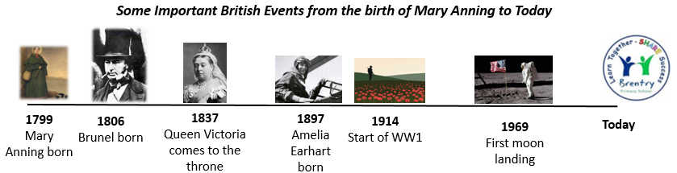

Dinosaurs lived over **65 million years** ago.

[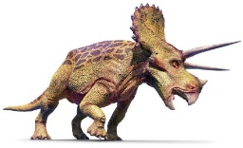](https://www.google.co.uk/url?sa=i&url=https://www.dkfindout.com/uk/quiz/dinosaurs-and-prehistoric-life/quiz-yourself-on-dinosaurs-true-or-false/&psig=AOvVaw3ZQjfApoMcJLahTB9nSN6E&ust=1589629190448000&source=images&cd=vfe&ved=0CAIQjRxqFwoTCOjG9OHktekCFQAAAAAdAAAAABAE)***How Can Children Today be Inspired by Mary Anning and Amelia Earhart?***

Amelia Earhart was born in **1897** in **America**.

When she was only 12, Mary and her brother found a fossilised **itchthyosaurus**.

Amelia was a **pilot** and an **author**.

Mary Anning was a **palaeontologist** and **fossil** collector.

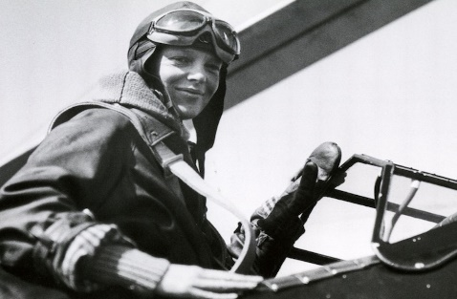[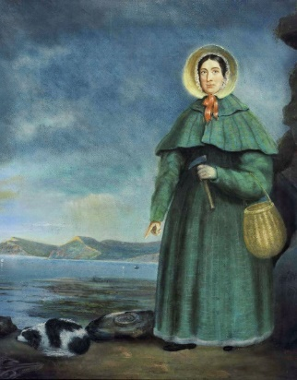](https://www.google.co.uk/url?sa=i&url=https://www.dorsets.co.uk/history/mary-anning.htm&psig=AOvVaw3nTUAhyjfgctbStT5YJeVZ&ust=1589629347315000&source=images&cd=vfe&ved=0CAIQjRxqFwoTCJDw9qnltekCFQAAAAAdAAAAABAR)

Amellia believed  
in **women’s rights** and stood up for what she believed in.

Although she made lots of important discoveries, Mary Anning was not allowed to join the **Geological Society** because she was a woman.

Amelia was the **first female pilot** to fly solo from **America to England** across the Atlantic Ocean.

**Palaeontologist:** someone who studies plants and animals that lived millions of years ago.

**Fossil:** the remains of plants and animals that lived millions of years ago.

**International:** involving more than one nation/ country

Mary Anning was born in **1799** in **Lyme Regis**. Lyme Regis is in a place called **Dorset** in South West England.