Brentry Primary School: History
Topic: Ancient Greece | Year: 5 | Term: 1
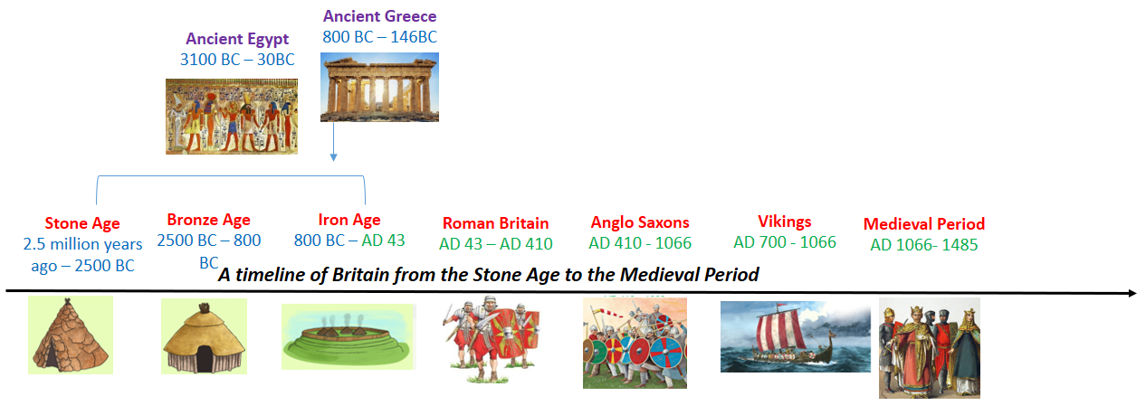
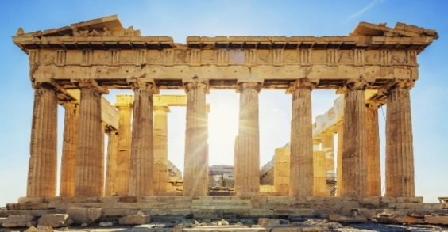
Greek City States
- Largely due to its physical geography, Ancient Greece had over a thousand city states (poleis) and each one ruled itself.
- The two main city states were Athens and Sparta and they differed greatly.
- Athens valued education and art, maintained their navy and introduced the political system of democracy where every male citizen had the right to vote.
- Sparta was ruled by Kings and a council of elders, maintained a powerful army and encouraged men and women to be fit and healthy.

Gods and Goddesses
- In trying to make sense of the world and explain how things came to be, Ancient Greeks believed gods and goddesses controlled everything.
- Temples and shrines were built for worship and festivals, prayers and offerings were given in the hope of good fortune in return.
- The twelve most powerful gods, headed by Zeus, were said to live on Mount Olympus. Here they held meetings and settled disputes, displaying tempers and emotions just like humans.
- Myths, legends and heroic stories have been passed down orally, telling of these deities and quests.

Why was the Ancient Greek Empire so Successful?
Ancient Greek Olympics
- The Olympics began in 776BC, originally as a religious event to honour Zeus.
- They took place in Olympia and began with short foot races where only Greek-speaking men competed, naked.
- Overtime, other events were added e.g. wrestling, javelin, discus, chariot racing
- The event took place every 4 years in August and a peace truce was declared among the city states for this month.
- An olive wreath made from Olympia’s sacred tree was given to the winner and a statue was built in their honour.
The Battle of Marathon (490 BC)
- King Darius of Persia planned to invade Athens to increase his empire. On arrival at Marathon, his army greatly outnumbered that of Athens
- The Athenians sent a messenger, Pheidippides, to run to Sparta asking for help. When faced with an outside enemy, the different states usually joined forces. He ran back with their answer.
- The Spartans had offered to help only once their festival celebrations were ended. This would be too late so the Athenians fought the Persians alone.
- Through better strategies and fighting techniques, Athens won the battle. The Persian army lost over 6000 men compared to only 192 Athenian soldiers.
- Pheidippides ran 26 miles from Marathon to Athens with news of the victory but then died.

Who were the Ancient Greeks?
- The first Greek civilisations were formed nearly 4,000 years ago, around 1600BC, by the Mycenaeans of Crete.
- During the “Dark Ages” of 11th – 9th century BC, the Greeks created settlements across the Aegean Sea and along the coast of Asia Minor.
- Control of good trading routes helped further growth and by the 4th century BC, King Alexander the Great of Macedonia, the most powerful Greek state, conquered the entire Persian Empire along the Mediterranean.
- This became known as the “Hellenistic World” and lasted until146 BC, when the Roman Empire was dominant.

