Brentry Primary School: History
Topic: Slavery | Year: 5 | Term: 2
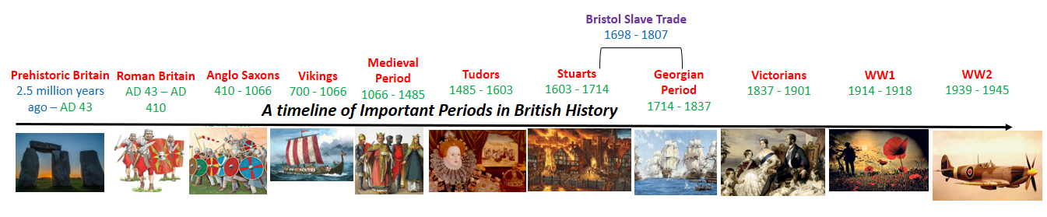
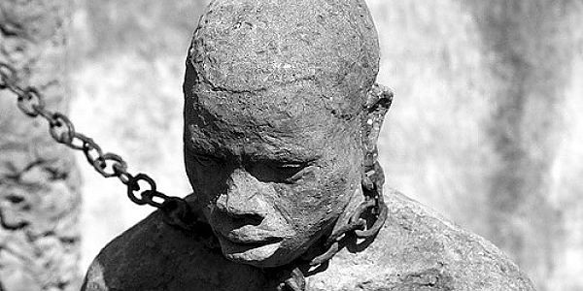
Abolition and Legacy
- Campaigns to abolish the slave trade emerged in the late 18th century. Granville Sharp, John Wesley and William Wilberforce led the British voice; Mary Prince & Olaudah Equiano gave the voice of Africa.
- The Abolition Act of 1807ended the British slave trade and work began to try and free remaining slaves.
- Parliament agreed this in 1833 and by 1838 had provided £20 million compensation – not for the enslaved but for their owners.
- Slavery still exists today, mostly due to worldwide poverty, but campaigns continue e.g. Fairtrade.
- The legacy of racism is challenged e.g. through the removal of Edward Colston’s statue in Bristol 2020.

Resistance and Rebellion
- Many of those captured resisted their enslavement, using opportunities to escape, overcome their captors or to harm them. Some, in despair, threw themselves overboard.
- Resistors deliberately worked slowly, damaged owners’ property, pretended to misunderstand instructions or attempted to run away. Severe punishments, if caught, acted as a deterrent.
- The “Underground Railroad,” helped by Harriet Tubman, saw hundreds of runaway slaves escape North.
- Most rebellions failed but the Haiti revolt 1791 and that of the Amistad (1839-40) were notable exceptions .
- Much evidence comes from the accounts of escaped or freed slaves such as Frederick Douglass and Olaudah Equiano.

The Transatlantic Slave Trade
- Europeans and Africans had traded goods for hundreds of years – cloth and metals were exchanged for items such as spices, gold and ivory.
- Forms of slavery already existed in Africa; the African people could not protect themselves against the guns of the slave traders and many African middlemen wanted wealth and power so enabled slavery.
- As a major international port, Bristol was well placed to provide the Americas with enslaved Africans.
- Many Europeans believed the African people were uncivilised and perpetuated this idea. In reality, African culture was packed with scientific, technological and medical advancements as well as skilled arts and crafts.
How was Bristol Involved in the Transatlantic Slave Trade?
The Middle Passage
- The voyage from West Africa to the colonies in the New World of the Americas was called the Middle Passage and usually took between 60 and 90 days to complete.
- The slave ships were designed with separate sections for men and women; weapons and a barricade to protect the crew from any revolt; netting to prevent anyone escaping overboard.
- Conditions on board the ship were horrendous: the enslaved Africans were chained together and crammed in tightly, often without enough space to stand.
- There was no plumbing and only limited ventilation so sickness and disease spread quickly. It is estimated that about 15% died on this part of the journey.
Plantations
- Sugar plantations spread quickly from the mid-16th century, reaching the Caribbean islands (Jamaica, Barbados & St Kitts) by the next century.
- Demand for sugar grew once Europeans mixed it with other items (e.g. coffee, tea, chocolate) – and consequently the need for slave labour also grew.
- Enslaved Africans were sold at auction like animals, often split up from their families.
- The slave owners were allowed to punish their slaves (e.g. by severe flogging) while those enslaved were stripped of their identity and had no rights at all.
- On sugar plantations in the West Indies, Africans worked in “gangs” according to age and strength, sometimes for up to 18hrs a day.
- Tobacco, coffee, rice and cotton plantations also grew up, spreading into regions like Virginia and Maryland.

