Starting School

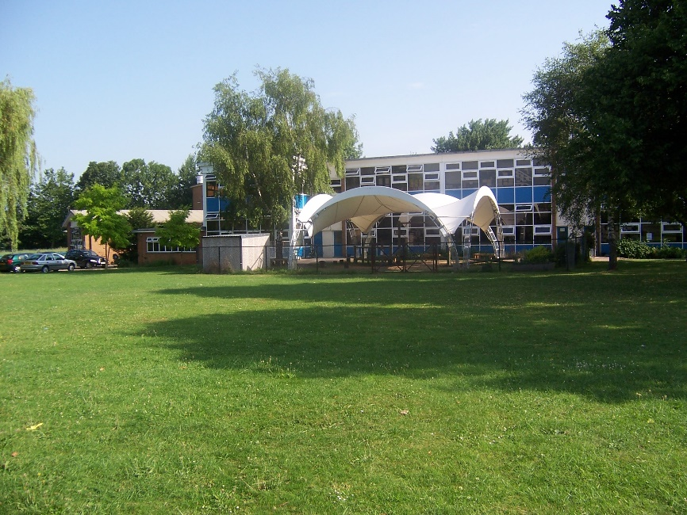

A Booklet for Parents.

**Welcome to Brentry School and**

**Potter Class!**

This booklet has been written to provide you with useful information about the school day and some of the things your child will need at school.

Please ensure you read all of the information carefully.

Please contact us if you have any questions or concerns. It is very important that we work as partners in your child’s education and achievements at school.

1

**Adults working in Potter Class.**

Miss Sally Millard – Class Teacher

Mrs Mandy Hancox – Teacher Assistant

**Times of the school day**

8.45am - 12.00p.m. = morning session (10.30 – 10.45a.m. = Playtime)

12.00 – 1pm = lunchtime

1 – 3.15p.m. = afternoon session

The children come into classroom through the outside door only. If you are late, please enter via the main office where your child will need to be signed in.

**Starting school**

We will settle the children in through small group sessions and home visits to get to know you and your child. Please read the transition document for upcoming sessions for you and your child.

2

**Uniform**

We have a school logo which is on our sweatshirts, fleeces, cardigans and polo shirts, and we also have our own P.E. kit. The children are asked to wear grey or black trousers/skirts, blue dresses, blue jumpers, white polo shirts and blouses. We also have school book bags.

We currently sale our school uniform from the website http://www.gooddies.co.uk/

You are able to purchase it before starting school through the website.

In reception, the children spend a lot of time outside having fun. Please make sure that your child comes to school with appropriate outdoor wear – e.g. A waterproof coat, wellington boots, a warm coat, a pair of gloves, a scarf, a hat, a sun hat etc………… Please bear in mind in reception we have lots of fun which can be messy!

Due to Health and Safety issues children are **not** allowed to wear jewellery at school. If your child wears earrings, please take these out at the beginning of the day**.**

We also ask that your child wears a suitable pair of shoes to school

**(no heels).** Velcro shoes are very useful if your child cannot tie laces.

**Please, please, please make sure that your child’s uniform, bags, coats, shoes etc are labelled with their name. Un-named uniform is very likely to be lost.**

3

**Playtime Snacks**

From Reception to Year 2 the children are entitled to free fruit. We usually have ours during the afternoons with our free milk.

The children are welcome to bring their own healthy snacks and will often feel hungry when we break at 10.30am. A snack from home is advised for this time.

**Lunchtime**

**School Dinners**

A school dinner menu for the term will be sent home.

*It is very important that we are made aware of any food allergies your child has, this needs to be completed on the dietary form in your welcome backs and returned to the school office* ***before*** *September.*

In Reception and KS1 all children receive free school meals. This means every child, every day can have a hot dinner. The school provides a choice of a hot meal, vegetarian or halal. As school dinners are free in reception these can be ordered on the day. If your child choses to have a packed lunch this can also be decided on the day.

**Packed Lunch**

If your child brings in a packed lunch from home please make sure that the containers are named. We encourage healthy eating and therefore sweets, chocolate bars and fizzy drinks are not allowed. Your child can also bring a carton/drinks bottle for lunch.

4

**Reading**

The children are taught phonics using a scheme called Twinkl Phonics. We teach phonics daily, once they are settled into school life.

When your child begins to learn phonics, we will hold a phonic workshop. This is to help parents understand and assist their child with learning how to read and write.

A Sharing book (story book) will be sent home when your child begins school. When they are ready, we will then send home phonically decodable books and key words for your child to begin practising to read.

Reading is a huge part of your child’s education. We value it as a life skill to help your child succeed. We expect all parents to help support our teaching of reading by ensuring they also spend time reading at home with their child.

In class, we have a reading reward system to help encourage children to read. Each time your child reads 6 times at home they will move along the chart to receive stickers and prizes.

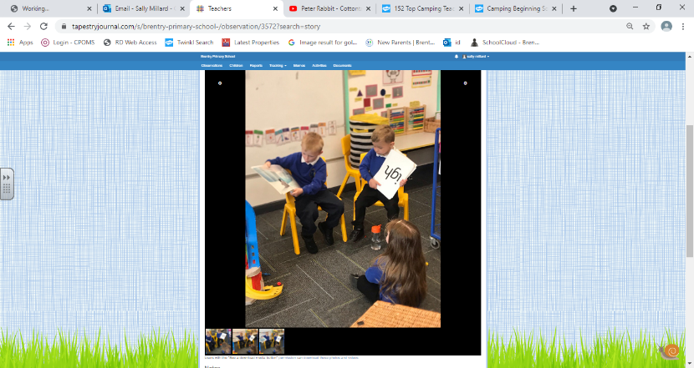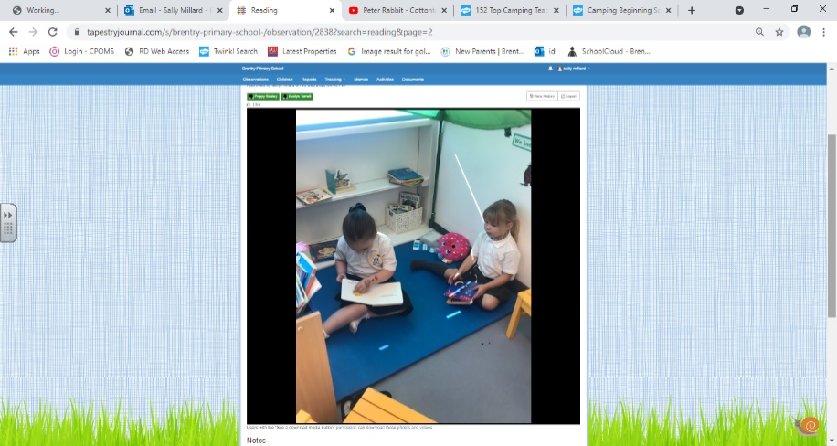

5

**Physical Education (P.E.)**

Although in reception a formal PE lesson is not required as part of the Curriculum we feel it is important for our children to learn about physical education.

P.E. is once a week on a Wednesday morning. In reception we usually practise getting ourselves changed in school and we ask for PE kits. We will let you know when your child will begin to need their kits (Usually term 2).

**Please make sure that your child’s P.E. kit is labelled with their name.**

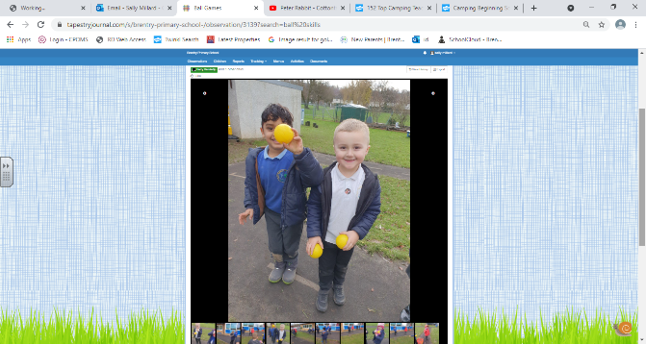

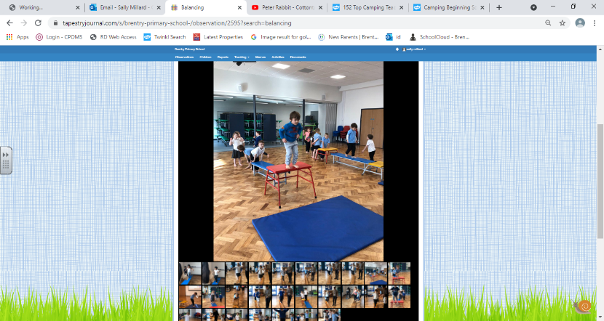

**Spare Clothes**

Children often get messy in reception and need a spare pair of clothes. Even if your child is fully potty trained accidents can happen especially in new environments. Therefore, we ask that all children have a spare set of named clothes in their bags, including; a pair of pants, socks, top and trousers.

8

**What can I do at home to help my child**

**prepare for school?**

We hope that your child will settle easily in to school life. For some children it is harder than it is for others. Please be assured that we will work closely with you to make sure that your child’s first experiences of school are positive and happy ones. Here are some ideas for you to do/practise with your child before September!

* Talk positively about your child starting school, including the activities he/she will be doing at school.

*Help your child to practise buttons and zips, putting their socks and shoes on and getting dressed by themselves.

*Encourage your child to use a knife, fork and spoon.

*Help your child to use the toilet by themselves and manage their own hygiene (washing and drying their hands etc).

*Share picture books, talking about the characters and events in the stories, read shop and road signs and sing nursery rhymes together.

*Encourage your child to count with you e.g. singing number songs, putting 3 oranges in to the bag at the supermarket, playing

co-operation games such as Snakes and Ladders and completing jigsaws puzzles together.

*Point out your child’s name for them to begin to recognise.

*Promote your child’s independence by encouraging them to ‘have a go’ on their own.

9

**General School information**

**Communication:**

Please feel free to contact the office or email if you have any questions regarding your child starting school.

0117 3532261

[Brentry.p@bristol-school.uk](mailto:Brentry.p@bristol-school.uk)

We are now inviting our new Parents to join our school Facebook page. We often post school messages, information and photos on the site. Please ensure if you join the group you do not share any of our school images.

**Sickness:**

If your child has sickness or diarrhoea they will need to have 48 hours away from school from the last time they were ill. Please phone the school office to report your child as absent.

**Entering site:**

Although our school has parking we do not permit parents to drive onto site for the safety of all pupils. Please walk your child onto the school site unless you are using breakfast or afterschool club.

**Breakfast & Afterschool Clubs:**

We host both breakfast and afterschool clubs on our school site. Please see our school flyer for Breakfast club and visit the Sport4Kids for after school club.

[Sport4Kids - Toddler & Kids Sports Activity Classes, Clubs and Camps UK](https://sport4kids.biz/)