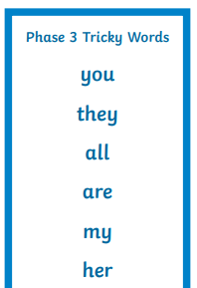

**Year 1 Common Exception Words – Level 3**



**Year 1 Common Exception Words – Level 2**



**Year 1 Common Exception Words – Level 1**

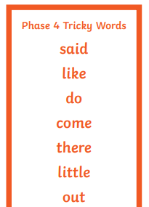

**Year 1 Common Exception Words – Level 4**

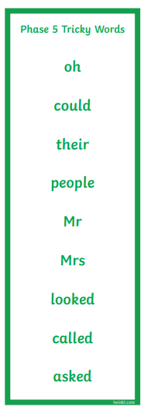

**Year 1 Common Exception Words – Level 6**

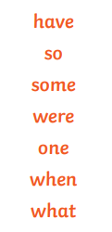

**Year 1 Common Exception Words – Level 5**