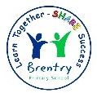
Brentry Primary School - Science
Topic: Forces | Year 5 | Strand: Physics

What will I know by the end of this unit?
We will learn about different types of forces such as gravity, friction, water resistance and air resistance.
We will learn about the use of mechanisms such as levers, gears and pulleys.

What do forces do? | 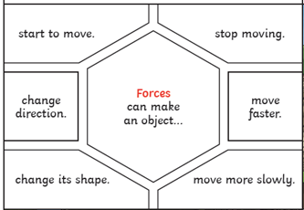
Who was Isaac Newton? | 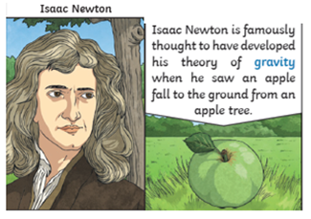
Examples of forces in action. | 