Brentry Primary School - Science
Topic: Living things and their habitats | Year: 5 | Strand: Biology

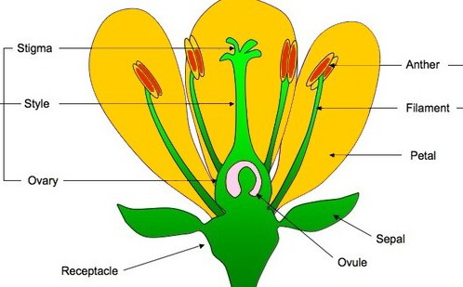
What should I already know?
- Animals can be grouped into vertebrates (and then further into fish, reptiles, amphibians, birds and mammals) and invertebrates
- Some examples of life cycles (including those of plants and humans)
- The processes of dispersal, fertilisation and germination
- Reproduction is one of the seven life processes.
- Parts of a plant, their features and what their functions are.
- The work of David Attenborough.
- The word metamorphic means ‘a change of form’ (in the context of rocks)

What will I know by the end of the unit?
What is  reproduction? | - Reproduction is when an animal or plant produces one or more individuals similar to itself:  - Sexual reproduction:  - requires two parents with male and female gametes (cells)  - will produce offspring that is similar to but not identical to the parent  - Asexual reproduction:  - will produce offspring that is identical to the parent  - requires only one parent
How do plants repro- duce?  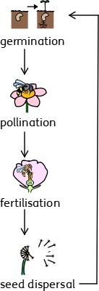 | - Male gametes can be found in the pollen.  - Female gametes can be found in the ovary (they are called ovules).  - Pollination occurs when pollen from the anther is transferred to the stigma by bees and other insects.  - The pollen then travels down and meets the ovule. When this happens, seeds are formed - this is called fertilisation.  - Seeds are then dispersed so that germination  can begin again.  - Some plants, such as daffodils and potatoes, can also produce offspring using asexual reproduction
What are  examples of  life cycles? | - The life cycles of mammals, birds, amphibians and insects have similarities and differences.  - One difference is that amphibians and insects go through the process of metamorphosis. This is when the structure of their bodies changes  significantly as they grow (for example, from tadpole to frog or caterpillar to butterfly).

Vocabulary
anther | the part of a stamen that produces and releases the pollen
bulb | a root shaped like an onion that grows into a flower or plant
cell | the smallest part of an animal or plant that is able to function  independently
dispersed | scattered, separated, or spread through a large area
dissect | to carefully cut something up in order to examine it scientifically
embryo | an unborn animal or human being in the very early stages of  development
fertilisation | male and female gametes meet to form an embryo or seed
flower | the part of a plant which is often brightly coloured and grows at the end of a stem
flowering | trees or plants which produce flowers
function | a useful thing that something does
gamete | the name for the two types of male and female cell  that join together to make a new creature
germination | if a seed germinates or if it is germinated, it starts to grow
life cycle | the series of changes that an animal or plant passes through from the beginning of its life until its death
mature | When something matures, it is fully developed
metamorphosis | a person or thing develops and changes into something completely different
ovary | a female organ which produces eggs
ovule | a small egg
petal | thin coloured or white parts which form part of the flower
plant | a living thing that grows in the earth and has a stem, leaves,  and roots
pollen | a fine powder produced by flowers. It fertilises other flowers of  the same species so that they produce seeds
pollination | To pollinate a plant or tree means to fertilise it with pollen.  This is often done by insects
reproduction | when an animal or plant produces one or more individuals  similar to itself
seed | the small, hard part from which a new plant grows
stigma | the top of the centre part of a flower which takes in pollen
structure | the way in which something is built or made

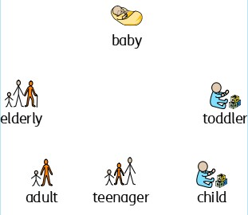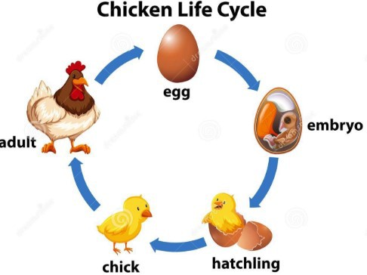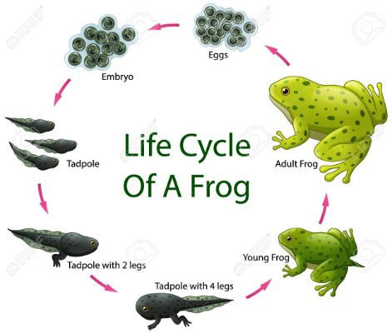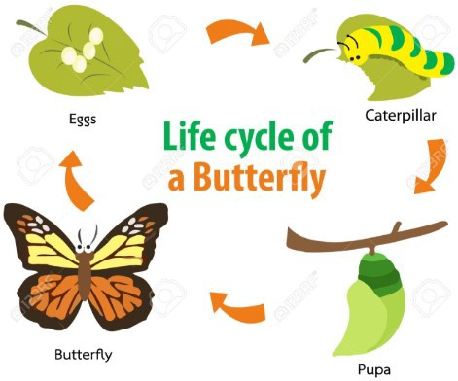

Investigate!
- Dissect a flower and identify the different parts of it. Label the different parts and explain their functions.
- Grow new plants from different parts of the parent plant, for example, seeds, stem and root cuttings, tubers, bulbs.
- Compare the life cycles of mammals, amphibians, insects and birds. What is similar about their life cycles? What is different?
- Observe life cycle changes in a variety of living things, for example, plants in the vegetable garden or flower border, and animals in the local environment.
- Compare the life cycles of plants and animals in the local environment with other plants and animals (in the rainforest, in the oceans, in desert areas and in prehis- toric times), asking pertinent questions and suggesting reasons for similarities and differences.
- Observe changes in an animal over a period of time (for example, by hatching and rearing chicks), comparing how different animals reproduce and grow.
- Compare what you already know about David Attenborough, and compare his work to that of Jane Goodall’s.

Brentry Primary School - Science
Topic: Living things and their habitats | Year: 5 | Strand: Biology
Question 7: Pollen transfer from insects is one example of how pollination hap-  pens. Name another. | Start of unit: | End of unit:

Question 1: Asexual reproduction  occurs when….(tick two) | Start of  unit: | End of  unit:
there is only one parent
there are two parents
the offspring is identical to the
parent
the offspring is similar but not
identical to the parent

Question 2: Place these events in the life cycle of a plant (1-4). One  has been done for you. | Start of unit: | End of unit:
fertilisation
pollination
germination
seed dispersal | 1

Question 8: You conduct an experiment to  investigate if some seeds germinate quicker than others. Name one thing you will do to  make the test fair. | Start of unit: | End of unit:

Question 3: The life cycles of amphibians and insects are similar  because….(tick two) | Start of unit: | End of unit:
they both give birth to live young
the offspring hatch out of eggs
they usually both undergo
metamorphosis
they can both fly

Question 9: Label where male and female  gametes can be found in the flower. | Start of  unit: | End of  unit:
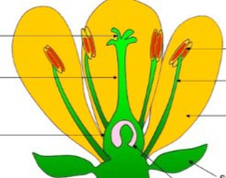

Question 4: Seed dispersal is part of a life process. Which life process is it  a part of? | Start of unit: | End of unit:
respiration
nutrition
reproduction
excretion

Question 5: Place these events of reproduction of a flower in order from 1-4. One has been done for  you. | Start of unit: | End of unit:
bees and other insects fly to another flower and transfer the pollen to the stigma
the pollen travels down the ovule
bees and other insects collect pollen  from the anther | 1
fertilisation happens with the pollen
meets the ovule

Question 10: Explain how fertilisation occurs  in a plant. | Start of  unit: | End of  unit:

Question 6: Which of these are  examples of metamorphosis? | Start of  unit: | End of  unit:
teenager to adult
caterpillar to butterfly
tadpole to frog
chick to hen

