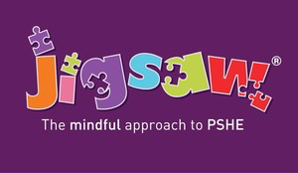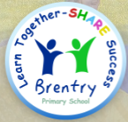Dear Parent/Carer,

Our PSHE curriculum is primarily delivered through the “Jigsaw” scheme of work, including the theme of Relationships and Sex Education. Lessons since September have focused on children’s emotional literacy, their self-esteem and the knowledge of who they are and how they relate to each other in a positive and healthy way. Term 6’s unit is “Changing Me.” This includes, in every year group, two or three lessons to help children understand the changes puberty brings and how human reproduction happens. (The younger years look at correct terminology for body parts, and the foundation learning to this unit; years 5 & 6 look more fully at puberty and reproduction.) At this time, we wish to remind you of your right to withdraw your child from this aspect of the PSHE curriculum. Please do let your class teacher know, in writing, if you wish your child withdrawn.

We hope, as always, you agree with us that this work is vitally important for children and that the Jigsaw programme provides a secure, comprehensive framework in which to deliver it.

A parent – carer guide can be found on our school website, alongside the Sex and Relationships policy, if you require further information.

Additionally, please do not hesitate to come and see me if you would like to view any of the materials and resources we use. With many thanks for your support

Mrs Garland

Year 3 Teacher

PSHE Lead