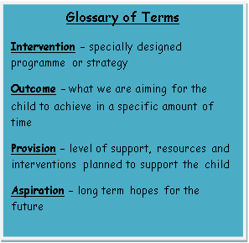

**EHCP**

An Education, Health & Care Plan (EHCP) is issued and will support the child until he/she is 25 years old. This is reviewed annually

**EHCP** **Assessment**

Children with long term needs, who receive continued support and intervention from external agencies, have an application made for an EHCP (Education, Health & Care Plan) assessment

**Support Plan**

For children who continue to require high levels of support and Early Intervention Funding (EIF) from the local authority, a Support Plan is drawn up by school staff, the pupil, parents and outside agencies. This is reviewed annually

**School Support Plus (for children who require intervention from outside agencies)**

For children who have received intervention through School Support, but continue to require a more in depth assessment, we can make referrals to the most appropriate outside agencies. These include: Educaiton P children who contine totargets and outcomes)to the quality first teachingth their child'ersonal targets, aspiratiEducation Psychology, Speech and Language Therapy, Bristol Autism Team (BAT), School Nurse, Occupational Therapy, Physiotherapy, North Star Outreach (Social Emotional & Mental Health Support), Primary Mental Health Nursing team and Community Paediatrics.

Regular meetings with parents/carers and children are held to write and review outcomes on Individual Learning Plans (ILP), or other bespoke action plans

Regular meetings with children and parents/carers are held to set up and review actions on Individual Learning Plans (ILPs) or Individual Behaviour Plans (IBPs)

**School Support (provision we offer children who require additional support/ intervention to the quality first teaching)**

Small group or 1-1 intervention, matched to a pupil’s needs, will be planned and delivered

Interventions include: Nessy, Twinkl Phonics Code Breakers, Numbers Count, Time to Talk, Socially Speaking, speech and language programmes and ELSA (emotional literacy support)

Targets/Outcomes on an Individual Education Plan (ILP) may, at this stage, be co-produced by the class teacher, parent/carer.

**Quality First Teaching (provision we offer everyone)**

Committed staff with up to date professional development. A positive, welcoming and nurturing ethos for all

Access to a full curriculum, monitored through teacher assessments. Resources in every classroom to support learning and enrichment opportunities to enhance retention of learning

Monitoring of lessons, learning walks and termly Pupil Progress meetings. Open door policy and regular meetings & workshops with parents/carers

Teacher Assistants who support whole class teaching, small groups and individual targeted support

Differentiated teaching in all subjects where learning is matched to all ability groups in the class

Parent consultation evenings twice a year and an open door policy for parents/carers to meet with their child’s class teacher

Updated September 2024