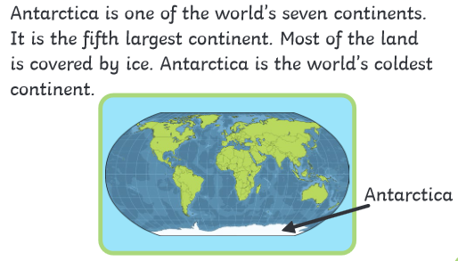

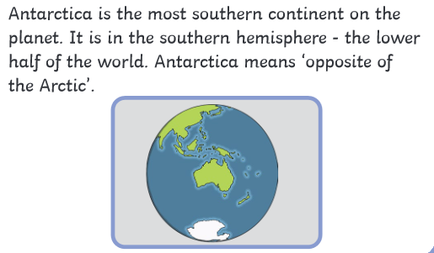

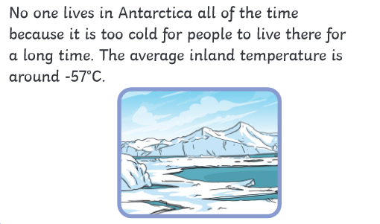

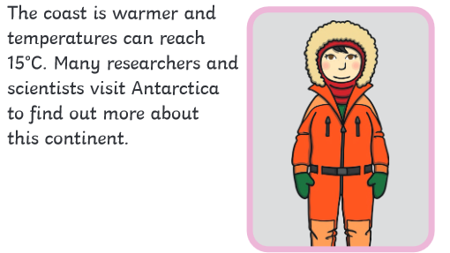

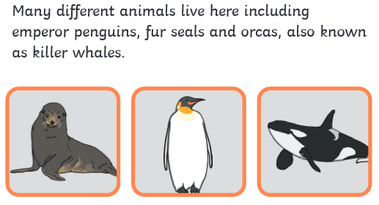

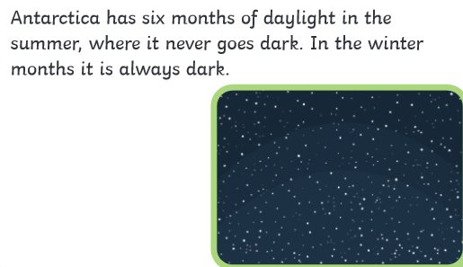

26.1.22 WALT: Answer questions VIPERS

1. What is most of the land covered by in Antarctica?

__________________

1. Why do people not live in Antarctica?

_________________________________________

1. Who visits Antarctica?

________________________________________

1. How many months of daylight does Antarctica have in the summer?
2. Is there any daylight in the winter in Antarctica?

__________________________

Would you like to visit Antarctica? Give reasons for your answer.

______________________________________________________________________________________________________________________________________________________________________________________________________________________________________

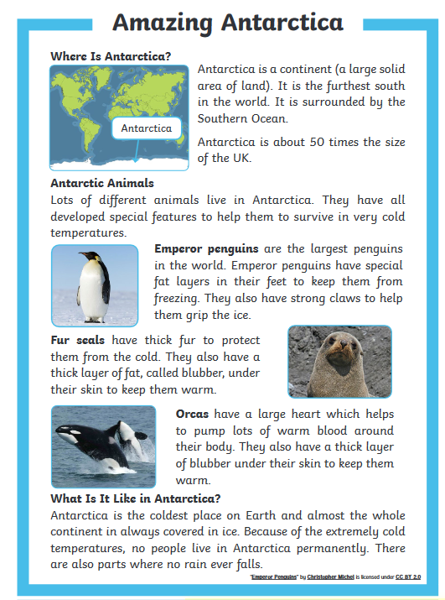

26.1.22 WALT: Answer questions VIPERS

