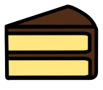
- I cut my cake into 10 pieces to share with my friends. There are five of us altogether. How many pieces will we each get?

- There are 30 children in the class. They need to be split into 5 groups. How many children will there be in each group?
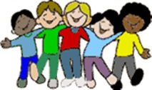
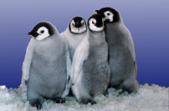
- Twenty penguins need to be put into 5 pools. How many will go in each pool?

- There are 40 Anglo-Saxons living in 5 round houses. How many live in each house?
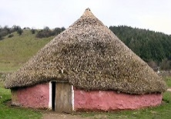
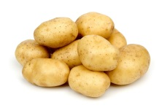
- There are 50 potatoes left in the pan and 5 children in the queue. How many potatoes will they each get?


- There are 55 paint brushes in the cupboard and 5 pots. How many paint brushes should go in each pot?

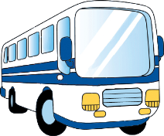
- 60 children need to go to the swimming baths. 5 buses are sent to take them there. How many children should go on each bus?

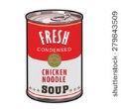
- A supermarket has 5 shelves for soup and 100 tins to put on them. How many tins should they put on each shelf?

