

**Level 6**

## Journey to the South Pole

Focus Words Check! Fill in the missing letters:

f ou , s o , la , i b, co b, n mb, li b,   
t m , bo b, c u

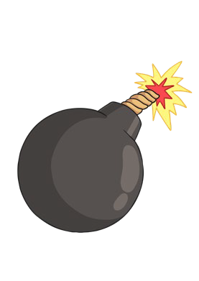Cut out the pictures and stick them in the correct whale. Write the matching word underneath

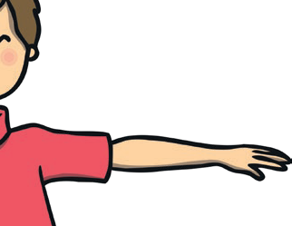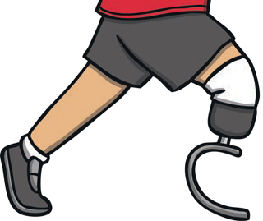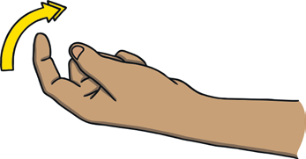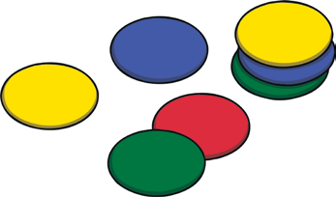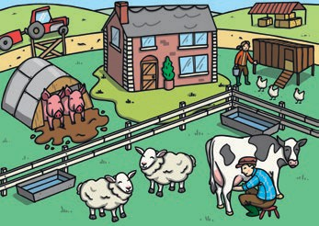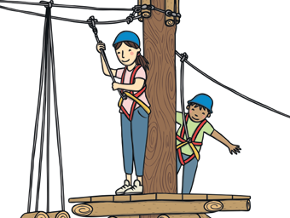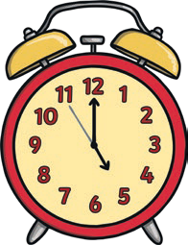

## Challenge

Find some other words with different spellings of the /m/ sound and draw or write them in the blank cut and stick boxes to add to the whales.

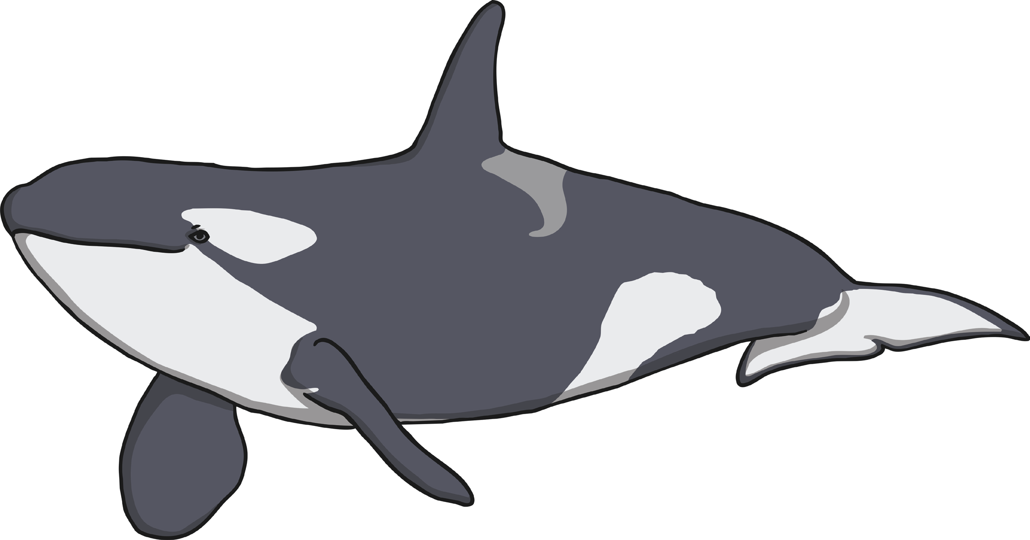

**twinkl.com**

# m



**twinkl.com**

# me



**twinkl.com**

# mb

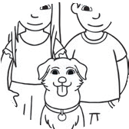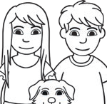

## Answers

Focus Words Check! Fill in the missing letters:

f**am**ou**s**, s**h**o**e**, la**mb**, **l**i**m**b, co**m**b, n**u**mb, **c**li**m**b, t**o**m**b**, bo**m**b, c**r**u**mb**

**Level 6**



**broom**

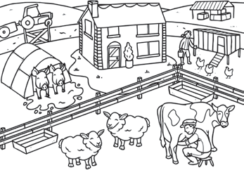

**farm**

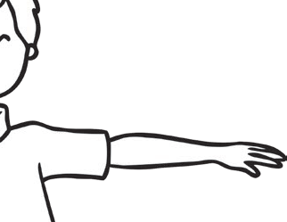

**arm**

**m**

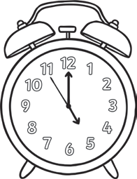

**alarm**



**steam**

**me**

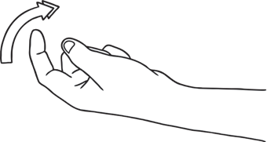

**come**

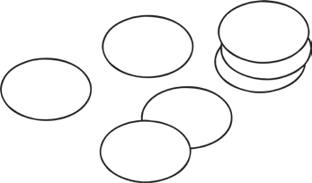

**some**

|  |  |  |
| --- | --- | --- |
|  |  |  |
| **climb** |  | **thumb** |

### **mb**

**comb**

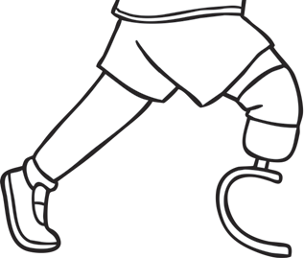

**limb**

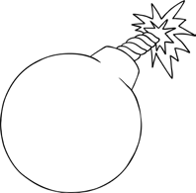

**bomb**



**visit twinkl.com**