24.01.22

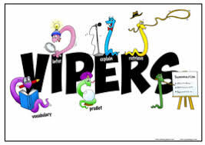 WALT: Sequence events from ‘The Emperor’s Egg’ 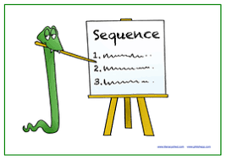

From the information, you have read in the book put the events of an Emperor penguins life in the correct order.

|  |  |  |  |  |
| --- | --- | --- | --- | --- |
| The male penguin must keep the chick warm and feed it. He feeds the chick something rather like milk that is deep down in a pouch in his throat. | Female Emperor penguins lay one egg in May or June. | The male penguin looks after the egg whilst the female penguin spends most of the winter swimming about, getting as fat as they can. | The male penguin swims in the sea. Finally, it is his turn to eat. | The female penguin returns. Every adult penguin has its own special call that they use to help find each other. |

 

