WALT: Understand why a Mosque is important to Muslims.
What is a mosque?  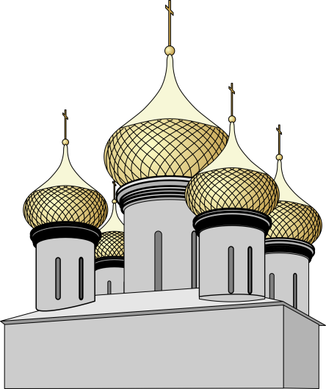 | A mosque is a place of worship for Muslims. They go there to pray. Prayer on a Friday is very important for Muslims and lots of people go to the mosque on that day.  Mosques also have spaces that are used for events such as weddings or funerals. Muslims also go to there to study and learn about Islam.
What does a mosque look like?  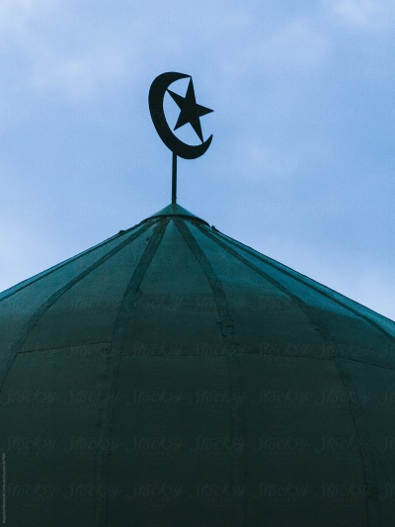 | Some mosques can be quite simple and others are much bigger. Mosques often have one or more domes. The crescent and star are seen on a dome as the symbol of Islam. There are no pictures of God in a mosque. They have a prayer room which is a large carpeted room. There is no furniture like chairs because Muslims pray on prayer mats on the floor.  There is a small tower called a minaret which is used to call people to prayer. There is a small alcove which points in the direction of Mecca. Muslims have to pray in the direction of Mecca.
What happens in a mosque? | Five times a day people go to pray in groups. They kneel on a prayer mat in the prayer room. Before Muslims pray, they must wash. They must also take their shoes off before they pray.
Who is in a mosque? | Muslims go to the mosque but you can visit even if you are not a Muslim. Men and women can go to pray but they have separate rooms to pray in. The Imam is the person who leads the prayer. He will recite from the holy book called the Quran.

- What day do lots of Muslims go to the mosque? ___________________
- Name three things that might happen in a mosque.
1___________________ 2 _________________ 3 ______________
- What is the symbol of Islam you might see on a dome?

- Tick which things you would find in a mosque.

Furniture Prayer room

Chairs Pictures of God

- What do Muslims pray on? ______________________

- What is the small tower called? ________________________

- What direction do Muslims have to pray in ? ___________________

- Name two things Muslims have to do before they pray.

1 _______________________ 2 _____________________________

- What does the Imam do in a mosque? ______________________________________________________
Tick if the statements of true or false.
 | True | False
Muslims only pray on a Friday.
Men and women pray separately.
All mosques are the same size.
You can only visit a Mosque if you are a Muslim.

