# To Antarctica!

Can you sort the jumbled words to spell **mb** saying /m/ words?

**Level 6**

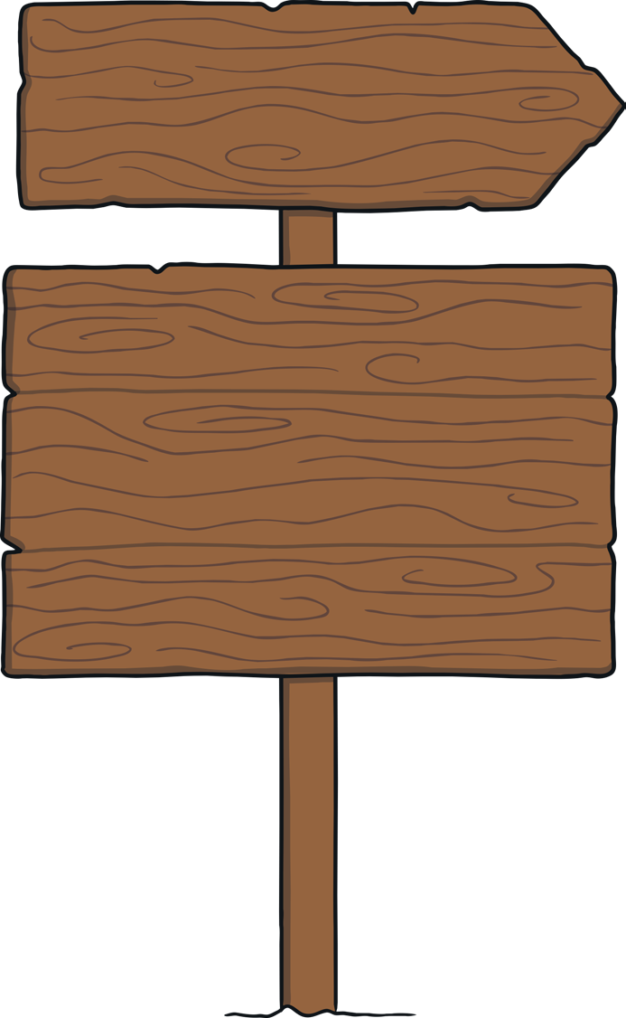

**ombc**



**bunm**



**blimc**



**hmbtu**



**umrcb**



**obmb**

# Challenge

How many **mb** saying /m/ words can you make using these letters? You may use each letter more than once.

**Level 6**



**p r u m b b**

**o t h u l a e c**