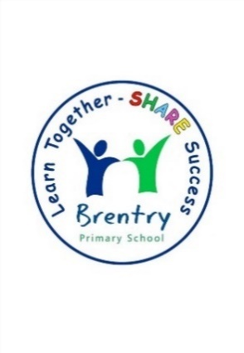  
Whole School Topical Overview

|  |  |  |  |
| --- | --- | --- | --- |
|  | **Autumn Term**  **(History Focus)** | **Spring Term**  **(Geography Focus)** | **Summer Term**  **(Art/ DT Focus)** |
| **R** | How have we changed since nursery?  Who was Beatrix Potter?  Who is in my family?  When and how did Christmas begin? | Antarctica  Space |  |
| **1** | How can children today be inspired by Mary Anning and Louis Braille?  How has life changed since the 1960s? | Our School  Our Country | Colour Chaos! / Sensational Salads  Landscapes and Cityscapes/ Pirate Paddy’s Packed Lunch Problems |
| **2** | How have Brunel and others helped make Bristol brilliant?  What made London go up in flames? | What a Wonderful World  Sensational Safari | L S Lowry / Dips and Dippers  Portraits / Moving Picture Traditional Tales |
| **3** | How did life change during prehistoric Britain?  What effect did the Roman Empire have on Britain? | Rainforests  Land Use | Fruits and Vegetables / The Great Bread Bake Off  British Artists / Juggling Balls |
| **4** | How did the Anglo-Saxons and Vikings struggle for the kingdom of England?  What were the achievements of the Ancient Egyptians? | All Around the World  Extreme Earth | European Artists / Battery Operated Lights  Insects / Edible Garden |
| **5** | Why was the Ancient Greek Empire so successful?  How was Bristol involved in the transatlantic slave trade? | Modern Britain  Exploring Eastern Europe | Pop Art / Programming Adventures  Plants and Flowers / Marbulous Structures |
| **6** | Who were the Maya and where did they live?  What was life like for British people during WW1? | Raging Rivers  Our Changing World | Central and South American Art / Automata Animals  Wildlife and Birds / Super Seasonal Cooking |