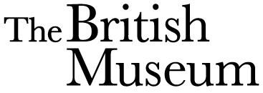

Dear Chaplin Class, Brentry Primary School,

The British Museum have heard that Chaplin Class are dinosaur experts and we are writing to you for your help.

We have found a box of coprolite in the Museum’s attic and wondered if you could investigate it for us.

There are 16 pieces of coprolite and we have wrapped them in tissue paper to protect them.

Please could you look inside the coprolite and find out whether the dinosaur was a carnivore or a herbivore. Then could you think about which dinosaur the coprolite might have come from.

If you could take some photographs too that would really help us in our investigations.

Many thanks for your help Chaplin Class.

We look forward to hearing from you.

Dr. John Ayres

Chief Scientist at The British Museum, London