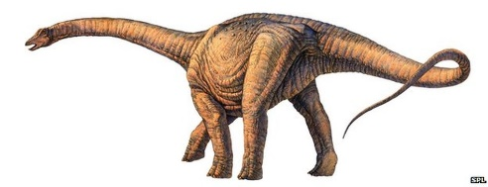Peep into the Past

Year 1 Term 1

|  |  |
| --- | --- |
| Literacy   * Introduction to VIPERS ( reading comprehension) * Daily phonics lessons * Fiction: re-telling stories with familiar settings   (*Class texts- Harry and the Bucketful of Dinosaurs and Fossil Girl*). Talk for writing.   * Non-fiction: writing labels and captions. Recounts   (*Class texts- What’s Under the Bed? Information books about Dinosaurs*) | Numeracy   * Place value to 10 * Reading and writing numbers to 10 (and beyond) * Counting forwards and backwards * Ordering numbers * One more than/one less than * Ordinal numbers ( 1st,2nd,3rd…) * Part/whole models ( introduction to addition) |
| Science 'Everyday Materials'   * Naming materials (paper,wood,plastic,metal,glass,fabric etc) * Properties of materials * Sorting materials * Testing properties of materials * Umbrella Investigation | Computing   * Computer Skills.   + Mouse control.   + Logging on and off.   + Launch an application.   + Save and open files in a folder.   + Drag objects from one place to another. |
| History   * Comparing the lives of Mary Anning and Amelia Earhart * Use clues, artefacts and pictures to find out about the lives of Mary Anning and Amelia Earhart. * What did they achieve and how can they inspire others * ‘WOW’ event ‘The BIG DIG!’ (September 2021.) * Learning about the past through an archaeological dig. | PSHE   * Being Me in My World * What makes a happy classroom? * Creating a Class Charter * Settling into the new routines and expectations of Year 1   Religious Education   * Christianity –Who is a Christian and what do they believe ? * What does it mean to belong to a faith community ? * The Christmas story. |
| Design & Technology/Art   * Sewing (D & T project) * Sketching, drawing and painting using different media (pencil, charcoal and paint) * Making fossils using clay   Music   * Sounds all around us * Focus our listening and exploring sounds from different sources * Explore and control instruments. | Physical Education   * Our PE days are Tuesday afternoons and Thursday mornings. * The children can come to school in their PE kit on Thursday. They will need to bring in their uniform in order to change after the lesson. * This term our PE sessions will focus on co ordination and balance. |