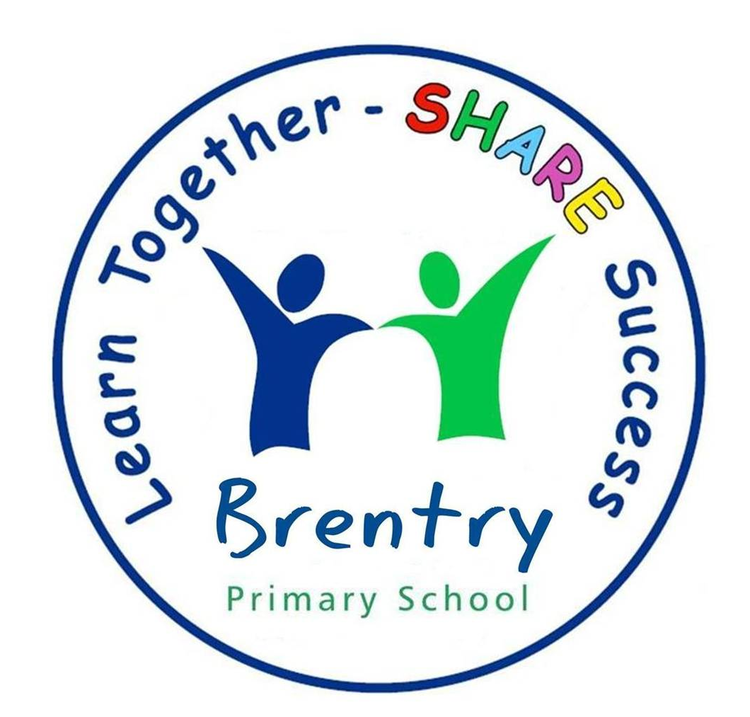

Dear Parent/Carer,

Welcome to Year 2 – we hope you have had a lovely summer. Our batteries have been recharged and we are excited to welcome all the children back to school on Wednesday. We will be having a ‘Back to School’ Meeting on Thursday 12th September but to keep us going till then we are going to outline some of the expectations of being in Year 2 in order to help the next few weeks run smoothly.

Staff

Mrs Ford
I have been teaching for 20 years and I joined Brentry 8 years ago. I have three boys of my own, which keeps me busy on the days I am not teaching. In fact, it’s sometimes a relief to be in work! I am teaching on a Thursday, Friday and alternate Wednesdays.

Mrs Collins
I love being at Brentry so much that I have been teaching here for quite a few years. In fact, I am now teaching children of pupils I taught at Brentry over 20 years ago! I have taught in all the year groups but am really pleased to be back in Year 2! I will be teaching on Monday, Tuesday and alternate Wednesdays. I will be teaching on the first Wednesday back after the Summer Holidays.

Mrs Tucker is our trusty sidekick; she is the ‘Mary Poppins’ of Year 2. She is our highly experienced teacher assistant and will be working in the class Monday – Thursdays with Mrs Caton in on Fridays. Unlike previous years Mrs Tucker will only be in Year 2 with us in the mornings. Other Classes will be having her support in the afternoon so please be aware we will be a one woman show in the afternoons!

We are a friendly bunch and are always here to support you. Please do pop in and say hello! A quick message in the mornings at the door is fine but if you need a longer discussion please wait until the end of the day when all the children have safely met their parents and we will be able to give you all our attention!

Reading Books:
We will be sorting out the reading books, matching appropriate books to match the children’s phonics ability. All children should receive a reading book by the end of the week. Please don’t worry if your child is given a different level to what they were on in Year 1, sometimes we have to refresh their memory by revisiting a level but they will quickly move onto the next stage. All children are expected to read as often as possible, ideally at least three times a week. When they have finished their book, they place their reading book in the reading tray at the front of the classroom to show us that it needs to be changed. We run a reward system for children, who regularly read at home: When the children read 10 times at home they receive a bronze certificate, 25 times they receive a silver certificate and 50 times a gold certificate! Please use your child’s reading record to communicate how your child is coping with their reading book at home.

Homework:
The children will have a weekly spelling test on a Wednesday morning. The children will need to show that they have practised their spellings by copying the word list three times in their spelling book. There will be new spellings set on 11th September, they will then be tested on the following Wednesday (18th).

P.E Kits:
The children have PE on Wednesday and Friday this term. On PE days children will be expected to come to school in their PE kit. Our first PE session will be on Wednesday 11th September. In Year 2 the children will take part in swimming lessons. These will be during Term 5. We will give you more information about these nearer the time.

Snacks and dinners.
Please feel free to provide your child with a healthy snack for playtime and we will also offer them free fruit if they choose it. We encourage the children to bring in their own water bottles that have their names clearly labelled on them.
Children in Year 2 are still entitled to free school lunches.

Belongings:
There is no need for children to bring in any personal belongings such as pencil cases etc. We will provide the children with all the resources they need.

Curriculum:
We have fun, exciting, engaging topics this year which the children will enjoy finding out all about. Please check our curriculum overview that will be on the class webpage and tells you everything we are covering this term.

We hope this has made our Year Two routines a little clearer. If circumstances change, we will keep you updated and please check on class webpage regularly.

In order to help your child settle into Year 2 quickly, please say goodbye to them at the door and allow them to come into the classroom independently. Looking forward to seeing you on Wednesday!

Laura Ford and Jill Collins

