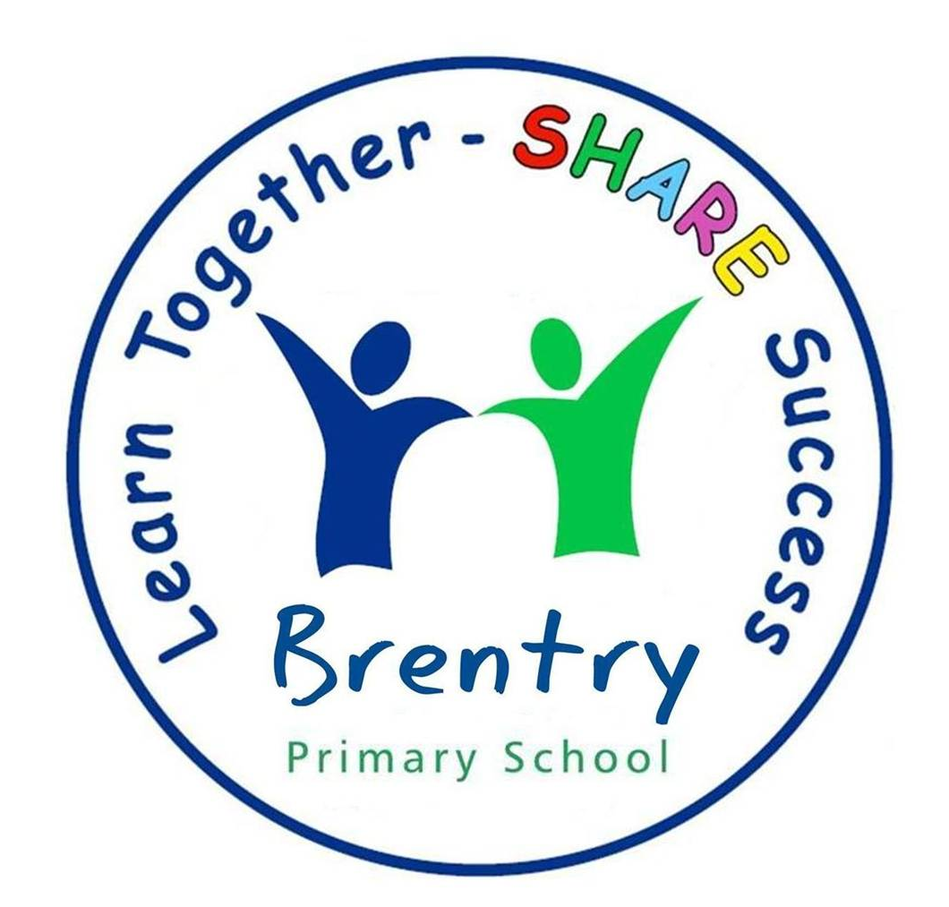

Dear Parent/carer,

Welcome back! It’s amazing how quickly the holiday flies by but it is good to be back – honest! All the children have managed to take in the Year 2 rules and routines really quickly which has certainly made our job easier. No doubt we will be having a back to school meeting soon, but to keep us going till then we are going to outline some of the expectations of being in Year 2 in order to help the next few weeks run smoothly.

Staff
Mrs Moore
For those who haven’t already met me, I have been teaching here at Brentry for 15 + years (I suddenly feel very old writing that!) and have taught in both key stages. I love this school and count myself very lucky to be working in the best year group (I may be a little biased) and I am really looking forward to working with Mrs Ford again. I will be teaching on a Monday, Tuesday and alternate Wednesdays. I am currently expecting my second child which is due on the 3rd January and I hope to work with the class right up to the end of Autumn term 2, Christmas (although I may become too big to stand in the doorway each morning!) Mrs Ford and I have already had lots of planning meetings and will be working in union to deliver the highest quality of teaching to all of the children in the class.

Mrs Ford
I have been teaching for 15 years too, but only joined Brentry two years ago. I have taught alongside Mrs Moore and am returning after a year of maternity leave. We are a great team and both experienced in year two. I am teaching on a Thursday, Friday and alternate Wednesdays. I am looking forward to returning to work and we have lots of exciting topics we will be learning about this year.

Mrs Fennel
We are really looking forward to working alongside Mrs Fennel who will be supporting a child in the class on a 1:1 basis.

Mrs Tucker is our trusty side-kick; she is the ‘Mary Poppins’ of Year 2 and this year will work with the children in Year 1 and 2. We are a friendly bunch so if we haven’t met you, please pop in and introduce yourself!

Reading Books:
We are busy sorting out the reading books, matching appropriate books to the children and all the children should have reading books within the next few days. The children are expected to read as often as possible. When they have finished their book they place their reading folder in the tray within the classroom and we change their book for them. We run a reward system for children, who regularly read at home: when the children read 15 times at home they receive a prize and move along Bob the Bookworms’ body, when they reach Bob’s head they receive a big prize! Please use your child’s reading record to communicate how your child is coping with their reading book at home.

Homework:
Homework is issued on a Wednesday and should be handed in by the following Wednesday. Your child will need to return their homework by putting their folder in the tray in the classroom. The children will receive a weekly literacy activity which may sometimes take the form of a worksheet or may need to be completed in their books. We will also be giving the children a maths activity to complete at home. If there are any keen beans who wish to complete extra homework just let us know!

Spellings:
The children will have a weekly test on a Wednesday. The children will need to show that they have practised their spellings by copying the word list three times in their spelling book.

P.E Kits:
The children have PE on Tuesday and Friday afternoon. If the weather is good please could you include outdoor shoes in their kit.

We hope this has made our year two routines a little clearer. Please if you have any questions come in and ask us.

Yours sincerely,

Claire Moore & Laura Ford

