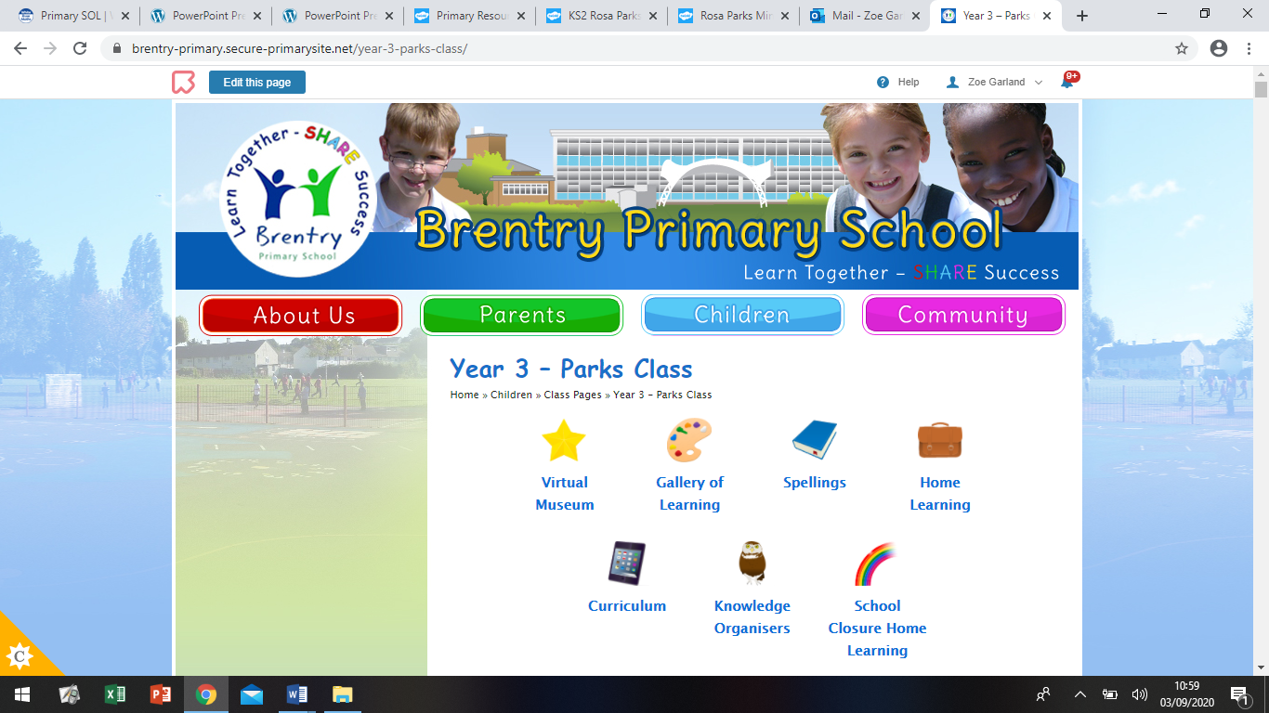Dear Parents/Carers,

Hello! Welcome back to a little slice of normality. The new term is almost here and we are ready and excited to welcome to children back to school. There will be some nerves but hopefully mostly excitement to get back into the classroom. The children will, I’m sure, need some time for adjustment but will settle back into school life in no time. We are here to support you and your family throughout this tricky time so please keep in close (not physically, of course!) contact with us so we can help if needed. There will be some anxious children but we aim to maintain the focus on mental health and wellbeing of the children to ensure we are supporting all aspects of the children’s development. In the absence of our usual ‘Back to School’ meeting, I have tried to outline what the year will look like in this letter. Any questions please let me know!

**Topics we are covering:**

**Science Units we will cover:**

Rocks

Forces and Magnets

Plants

Working Scientifically

Light

Animals including Humans

Stone Age to Iron Age

Roman Britain – (Usually Project time but still TBC)

UK Land Use

Rainforests – (Usually Project time but still TBC)

Fruits and Vegetables

British Artists

**Extra information:**

* PE days are on Mondays (indoor) and Thursdays (outdoor) from week 2 of school, full school uniform on 7.9.20 as it as our first day back to school and will not be doing PE. We will do PE on Thursday (10.9.20) so please ensure your child is in PE kit on that day.
* Children should come dressed in appropriate PE kit (pale blue polo, black shorts/leggings/tracksuit bottoms and trainers.) Children should be dressed for the weather; especially on Thursdays as we are outdoors, (sweatshirt/jumpers/tracksuits will be needed throughout the autumn and winter).
* Homework is still in discussion due to the potential cross contamination between home and school but will let you know ASAP about that one. **IF** homework goes ahead, it is due in on a Tuesday and goes out the following Wednesday.
* Reading books are now allowed to be sent home and it is the expectation that the children in Year 3 read **every day at home**, even if just for 5 minutes. The children should have their reading book and record every day. This will be monitored in school and the children will have rewards for reading. These will include raffle tickets and prizes from the prize box.
* There will be less opportunity to chat at the door in the morning due to social distancing that is mandatory so if you have something quick you need to say (rather than an in depth discussion), write it in your child’s reading record as this gets checked every morning. I will respond in there too.
* All children (for now) will be allowed Packed Lunches only. These will be eaten outside if it is good weather or in the classroom if not. Please refrain from sending your child into school with ‘messy’ lunches and snacks if possible. This is only because we don’t have cleaners for the classrooms at lunchtime so we need to try and keep sticky messes to a minimum! If you are having a Free School Meal for your child, you still need to send your child into school with a healthy snack for play time. The children will undoubtedly be extra hungry at first while they get used to the busy routine of the school day, so extra is always good to keep them going!

Please do let me know if there are any other questions, but hopefully they will be answered as the days go on! We don’t have all the answers but are trying our hardest to ensure the children have the best year yet!

Miss Garland