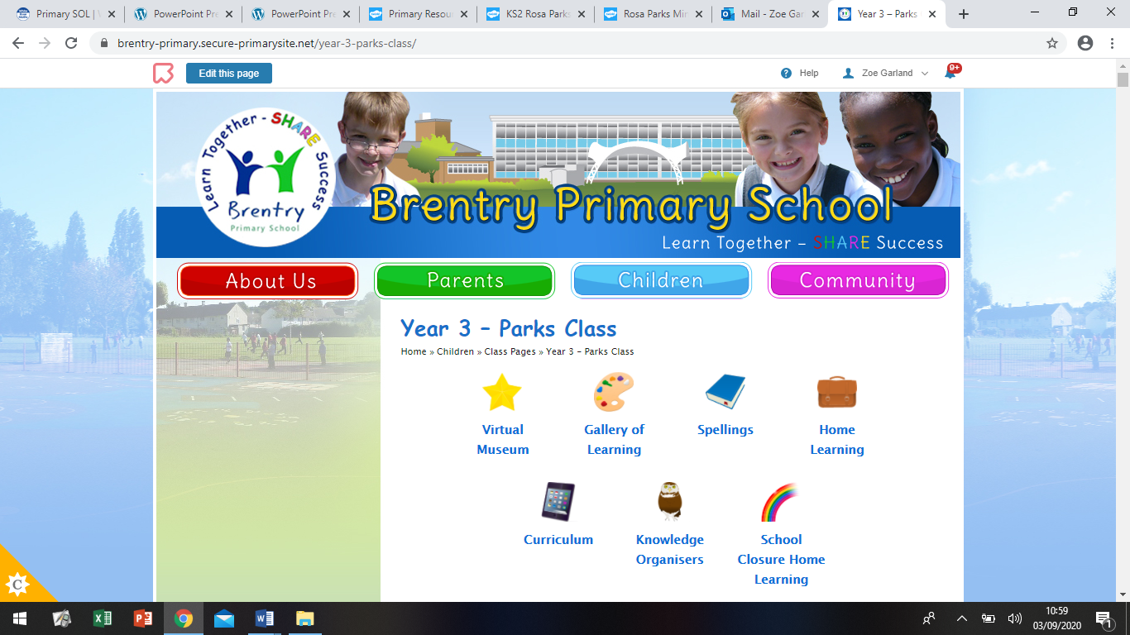Dear Parents/Carers,

Hello! Welcome back to a little slice of normality. The new term and new school year is here and we have been very excited to welcome the children back to school! They have had a few days to settle in now and hopefully routines are starting to take place and you are getting into the swing of things once again!

It really does feel like just yesterday we were waving the children off for the summer! Here is some information you might need to know before our ‘Back to School’ meeting next week (over Zoom). During the Zoom meeting, you will be informed of topics covered, expectations, rewards/sanctions, timetables etc. and will have the opportunity to ask any questions!

**Key Information:**

* PE days are now on **Tuesdays** (indoor) and **Thursdays** (outdoor) from week 2 of school. (It was due to be on a Monday, but Yoga has been booked for Mondays, so the hall is out of use to us. Our Yoga slot (each class completes one term) will be confirmed.
* Children should come dressed in appropriate PE kit (pale blue polo, black shorts/leggings/tracksuit bottoms and trainers.) Children should be dressed for the weather; especially on Thursdays as we are outdoors, (sweatshirt/jumpers/tracksuits will be needed throughout the autumn and winter). We have already been caught out in the rain and it’s only week one!
* Homework is still in discussion, **IF** homework goes ahead, it goes out on a Wednesday and is due in for the following Tuesday, to give me a day to mark/organise the next set. Homework will mainly comprise of Spellings/Times Tables.
* Reading Records have already gone home and it is the expectation that the children in Year 3 read **every day at home**, even if just for 5 minutes. The children should have their reading book and record every day. This will be monitored in school and the children will have rewards for reading.
* If you need to give me a quick message, you can use your child’s Reading Record to send me a small note as I check them daily. I can also respond to you in there. We all know how busy it can be in the mornings!
* Please send your child into school with a healthy snack for playtime. The children will undoubtedly be extra hungry at first while they get used to the busy routine of the school day, so extra is always good to keep them going! A water bottle is also a must, to keep hydrated and ensure concentration throughout the school day.

Please do let me know if there are any other questions. Our Zoom ‘Back to School Meeting’ will be held on **Monday 13th September at 4pm**. The details of the meeting will be sent via School Comms for security. I really hope you can make it!

Mrs Garland