**Year 4 Autumn Project (History Focus): Ancient Egypt**

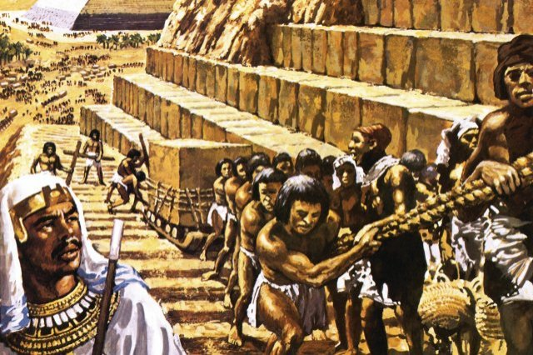

**Set:** Thursday 19th November

**To be handed in:** Monday 14th December

|  |  |
| --- | --- |
| **Option** | **What I’m looking for:** |
| *Design and construct a model pyramid.*  Try to include your original design when you hand in your project. It would also be lovely to see pictures of you at work! | Creativity and attention to detail  Range of materials used (you don’t need to spend money – recycled materials are great)!  Overall quality of the finished product – will it stand the test of time? Has a lot of care been taken? |
| *Create a PowerPoint or research booklet to present to the class about an aspect of Ancient Egyptian civilisation that you would like to be an expert in: buildings, language, religion, traditions, games, fashion.*  For example, a person researching pyramids might like to include the following facts: what pyramids were used for, what could be found inside them, how they were constructed, information on one or two famous pyramids. | In-depth research – but put into your own words (not copied and pasted information)!  A range of ICT skills shown  Clear presentation to the class |
| *Follow a recipe for Ancient Egyptian bread.*  Try to include the recipe you followed (there are lots online) and some reflections: did you like the taste, what was tricky, what bit was easiest, does it remind you of anything you have tasted before? Unfortunately, you cannot bring in any for us to try in the current circumstances, but it would be lovely if you could take some pictures of you cooking! | Attention to detail resulting in a successful bake.  Thoughtful reflections, which help us to understand the process and what you thought of the outcome. |

*Pupils are required to complete* ***one*** *of the following tasks:*