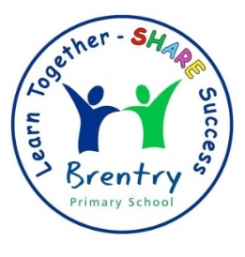

Brentry Primary School
  - Early Years Foundation Stage (EYFS) Policy

The Early Years Foundation Stage (EYFS) sets the standards for the learning, development and care of children from birth to five. At Brentry Primary School, children join the Reception class in the academic year in which they turn five. Working in partnership with parents and carers, we enable children to begin their journey as confident, curious, and successful learners for life.
This policy applies to school‑based EYFS provision and aligns with the EYFS statutory framework for group and school‑based providers (DfE), including the versions published for 2024 and those coming into force from 1 September 2025.
Our approach is underpinned by the four EYFS overarching principles:
- A Unique Child – every child is a competent learner who can be resilient, capable, confident and self‑assured.
- Positive Relationships – children learn to be strong and independent through warm, secure relationships.
- Enabling Environments – provision that responds to individual needs and interests through strong partnerships with parents/carers.
- Learning and Development – recognition that children learn in different ways and at different rates across the seven areas of learning.

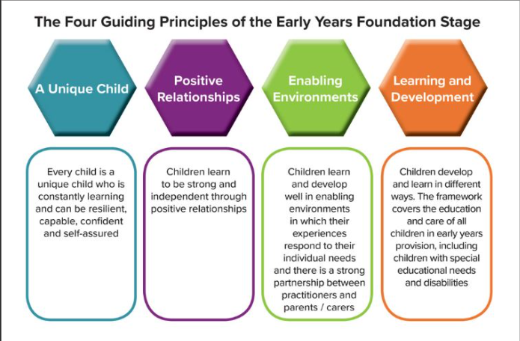

A Unique Child
We recognise each child as an individual with their own interests, learning styles and rates of development. We nurture self‑esteem, wellbeing and independence through positive feedback, high‑quality interactions and a responsive curriculum that values effort, persistence and celebration of success. Our provision promotes children’s health, safety and welfare in line with the EYFS safeguarding and welfare requirements for school‑based providers.
We are committed to equality of opportunity for all pupils and staff. The curriculum reflects cultural diversity and prepares pupils for life in modern Britain. We challenge discrimination and bias and ensure our environment, resources and interactions are inclusive and representative of our community.

Inclusion / Special Educational Needs (SEND)
All children and their families are valued at Brentry Primary School. Children are treated as individuals and have equal access to all provisions available. All children are encouraged to achieve their personal best and planning is adapted to meet the needs of all groups and abilities. Assessments take into account contributions from a range of perspectives to ensure that any child with potential special educational needs is identified at the earliest possible opportunity. Early identification of special needs is crucial to enable staff to support the development of each child. Concerns are always discussed with parents/carers at an early stage and the school’s SENDCo is called upon for further information and advice. Appropriate steps are taken in accordance with the school’s Inclusion policy for SEN.
We meet the needs of all our children through:
- Planning opportunities that build upon and extend children’s knowledge, experience and interests, and develop their self-esteem and confidence;
- Using a wide range of teaching strategies based on children’s learning needs;
- Providing a wide range of opportunities to motivate and support children and to help them to learn effectively;
- Providing a safe and supportive learning environment in which the contribution of all children is valued;
- Using resources which reflect diversity and are free from discrimination and stereotyping;
- Planning challenging activities for children whose ability and understanding are in advance of their language and communication skills;
- Monitoring children’s progress and taking action to provide support as necessary.
Safeguarding and Welfare
Keeping children healthy, safe and well is central to our practice. Key features include:
- Safeguarding policies and procedures that reflect current statutory expectations, including safer recruitment, managing allegations, whistleblowing, online safety and staff conduct.
- Safer eating: children are kept within sight and hearing of an adult while eating.
- Use of electronic devices: our policy covers all devices with imaging and/or sharing capabilities (e.g., mobile phones, tablets, smartwatches), not just phones and cameras.
- Health and hygiene: we promote good health, manage illness and infection control, and maintain high standards of hygiene consistent with school policies and the EYFS. Fresh drinking water is available, dietary needs are recorded and acted upon, and safe food practices are followed.
- First aid: at least one person with a current full paediatric first aid (PFA) certificate is on the school site at all times children are present and accompanies any outings.
Positive Relationships
Children thrive when they feel safe, known and valued. Staff build warm, respectful relationships that support independence, emotional security and effective learning. High‑quality interactions scaffold language, model thinking, and extend play. We actively teach routines and expectations, supporting self‑regulation and pro‑social behaviours through positive guidance consistent with the EYFS and our school behaviour policy.
Parents as Partners
Parents and carers are children’s first and most enduring educators. We work in partnership through:
- Transition activities, induction meetings and stay‑and‑play sessions.
- Regular communication (class pages/newsletters/meet‑the‑teacher/learning workshops).
- two parent‑teacher meetings and an end‑of‑year EYFS Profile report.
- Opportunities to contribute observations and celebrate learning, including via our secure online communication platform, Class Dojo), in line with data protection and safeguarding policies.
Practitioners use their professional judgement for assessment.
Enabling Environments
Our indoor and outdoor environments are thoughtfully planned to provide continuous provision across the seven areas of learning, enriched by enhancements that respond to current interests and next steps. High‑quality resources promote independence, exploration and sustained shared thinking. Provision is inclusive and representative, countering stereotyping and reflecting our community. Risk assessments are in place for the environment, activities and visits, and are reviewed regularly in line with our whole‑school procedures and the EYFS.
Learning and Development
Children access a broad, balanced and ambitious curriculum shaped by the EYFS educational programmes and the Characteristics of Effective Teaching and Learning.
These are:
-Playing and exploring;
-Active learning;
-Creating and thinking critically.

Learning is delivered through a balance of child‑initiated play and adult‑guided experiences, with increasing adult direction as children are ready, enabling a smooth transition to Year 1.
We teach across the seven areas of learning:
Prime areas:
-Communication and Language;
-Physical Development;
-Personal, Social and Emotional Development.
Specific areas:
-Literacy;
-Mathematics;
-Understanding the World;
-Expressive Arts and Design.

Assessment
- Assessment at the start of Reception: The Reception Baseline Assessment (RBA) is administered within the first six weeks.
- Ongoing assessment: practitioners draw on their knowledge of the child and professional judgement to inform next steps;
- End of Reception: the EYFS Profile (EYFSP) is completed for each child and shared with parents/carers and Year 1 staff to support continuity.
Health and Safety
We maintain robust procedures for risk assessment, first aid, accident and incident reporting, fire safety, infection control, and safe storage/use of substances and equipment. Our safeguarding policy includes clear procedures for the secure storage and appropriate use of mobile phones, cameras and any device with imaging/sharing capabilities. Staff attire supports safe, active engagement with children. Educational visits follow school and local authority procedures with suitable ratios and risk assessments.
Medicines: We follow DfE and school policy on medicines. Prescription/non‑prescription medicines are administered only with written parental consent and in accordance with training where required. We keep a written record each time medicine is administered and inform parents on the same day.
Transition
From Pre‑school / Feeder settings
To secure a smooth start, we provide:
- Induction meetings, home/school information exchanges, and taster sessions for children.
-Home visits give staff opportunities to visit children at their own home. This gives staff an opportunity to get to know a child in their own environment and discuss any issues with parents/carers.
- Opportunities for staff to liaise with feeder settings and review any relevant records.
- Additional transition support where a child’s needs warrant it.
From Reception Class to Key Stage 1
In the summer term, teachers complete the EYFS Profile and provide a narrative on the Characteristics of Effective Teaching and Learning to inform Year 1 planning. Year 1 staff build on children’s prior experiences, gradually increasing the proportion of adult‑directed learning while maintaining opportunities for purposeful play and exploration.

Reviewed: January 2026
Next review: January 2027
Summary of Changes from the Most Recent EYFS Curriculum
1. Separate frameworks for childminders vs school‑based providers (policy applies to school‑based only).
2. Supervision during eating clarified: sight and hearing.
3. Safeguarding policies must cover all imaging/sharing devices.
4. Assessment evidence: physical evidence not required.
5. EAL wording: providers may support home language.
6. Safeguarding strengthened from Sept 2025: safer recruitment, training, privacy in toileting, emergency contacts, attendance follow‑up.
7. Students/trainees must have PFA to count in ratios.
8. Nutrition guidance mandatory consideration from Sept 2025.
9. Reception Baseline Assessment to include digital elements from 2025/26.

EYFS Compliance Checklist
- Safeguarding policies include all imaging/sharing devices and safer recruitment steps (references required from Sept 2025)
- Staff ratios: Reception class follows statutory ratios for school-based settings
- Paediatric First Aid: At least one PFA-trained staff on site; students/trainees must hold PFA to count in ratios (Sept 2025)
- Supervision during meals: Children must be within sight AND hearing of an adult
- Nutrition: Apply updated national guidance from Sept 2025 unless strong reason not to
- Electronic devices: Policy covers phones, tablets, smartwatches, and any imaging/sharing device
- Assessment: No requirement for physical evidence; use professional judgment
- EAL: Providers may support home language while promoting English
- Reception Baseline Assessment: Complete within first 6 weeks; prepare for digital elements from 2025/26
- EYFS Profile: Complete for each child at end of Reception and share with Year 1

