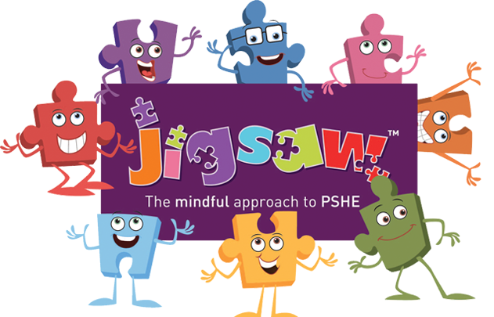

PSHE
Visual Review!
Autumn 2025
What I’ve been up to…
- Implemented new Jigsaw scheme of work
- Updated PSHE/RSE policies.
- Saved new documentation on the school website to share with parents
- Delivered whole school themes to raise the profile of PSHE
- Updated yearly calendar of PSHE related events
- Held a ‘Walk through’ of PSHE including conferencing and book look
- Attending bi-termly zoom meetings to network with other PSHE leaders
- Complete action plan for 2025
- Introduce Floor Books for monitoring learning in PSHE
- Consider options for assessment- if any
- Continue to use networking to gain understanding of good practice elsewhere
- Deliver staff meeting to monitor the subject, check standards, support staff
- Hold a ‘Walk through’ to gain understanding of what PSHE looks like
- Continue to raise the profile of PSHE through whole school themed days
- Introduce and implement new scheme ‘No Outsiders’
What I need to do next…

